IIT Hyderabad fabricates device for early diagnosis of heart attack
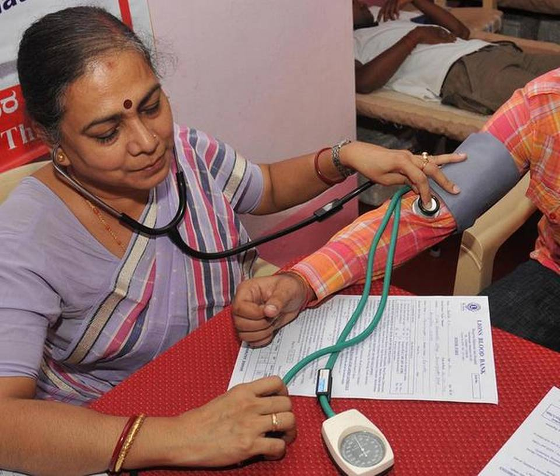

The microfluidic device can detect the biomarker even at low concentrations
A cardiac biomarker — cardiac troponin I — that is widely used for early diagnosis of acute heart attack can now be detected in about three minutes and even when present at very low concentration. And the detection can be done at bedside. This has become possible with the development of a microfluidic device by a team of researchers from the Indian Institute of Technology (IIT) Hyderabad.
The heart cells that get damaged during heart attack cause the expression of cardiac muscle proteins such as the biomarker cardiac troponin I, which get released into the blood. Detecting the biomaker in the blood serum helps in early diagnosis of heart attack.

Superior performance
Commercially available assays have limitations in terms of both sensitivity and time taken for detection. These assays cannot detect when the biomarker is present at concentrations below 0.02 nanogram per ml and take a long time for detection. In contrast, the microfluidic device developed by the team led by Renu John from the Department of Biomedical Engineering at IIT Hyderabad can detect the biomarker even when the concentration is as low as 0.005 nanogram per ml.
“Our device can detect the biomarker over a wide range — from 0.005-100 nanogram per ml,” says Prof. John. Serum samples from patients were used for testing the device. The results were published in the Journal of Materials Chemistry B.Commercially available assays as well the microfluidic device use the same antibody to bind to the biomarker. But the way the device has been constructed makes the difference in terms of better sensitivity and rapid detection.
Rapid detection
The researchers have successfully integrated the microfluidic device with chitosan-coated nickel vanadate nanospheres to enable rapid detection and better sensitivity.
The outer surface of the nanospheres is first coated (functionalised) with the antibody that binds to the biomarker. Since the nanospheres have greater surface area, more antibodies are present on the surface thus increasing the chances and ability to bind to the biomarker. The functionalised nanospheres are then coated on the working electrode that is present in the microfluid device chip.
“The integration of the nanospheres which detect the biomarker with the compact microfluidic device speeds up the detection process,” says Nawab Singh from IIT Hyderabad and first author of the paper.
“When the patient’s serum is introduced into the microfluidic device, the biomarker present in the serum binds to the antibodies present on the nanospheres. This causes a change in the current flow at a microamphere level,” explains Prof. John. “The electrochemical response of the sensor changes in response to a change in the concentration of the troponin I biomarker causing a change in the current flow.”

Bedside device
Since the microfluidic device can be made tiny, detection of the biomaker can be made right at bedside.
“This is a proof-of-concept work. We have to undertake large trials involving many patient samples before it can be used commercially,” says Prof. John.

Source: The Hindu
Date: 01-07-2019

