**Synthetic Efforts Towards the Synthesis of**

**(Z)-N-(2-(1Himidazol-4-yl)ethyl)-3-(4-hydroxy-3-methoxyphenyl)-2 methoxy acrylamide**

A Project Report

Submited to the Department of Chemistry

Indian Institute of Technology, Hyderabad

As part of the requirement for the degree of

Master of Science

By

**Diksha Sharma**

Roll no. CY17MSCST11007

Under the supervision of

**Dr Faiz Ahmad Khan**



DEPARTMENT OF CHEMISTRY

INDIAN INSTITUTE OF TECHNOLOGY, HYDERABAD

**Contents**

Abstract…………………………………………………………………

1. Introduction

2. Results and Discussions

3. Conclusion

4. Experimental Section

5. References

6. Supporting Information

**APPROVAL SHEET**

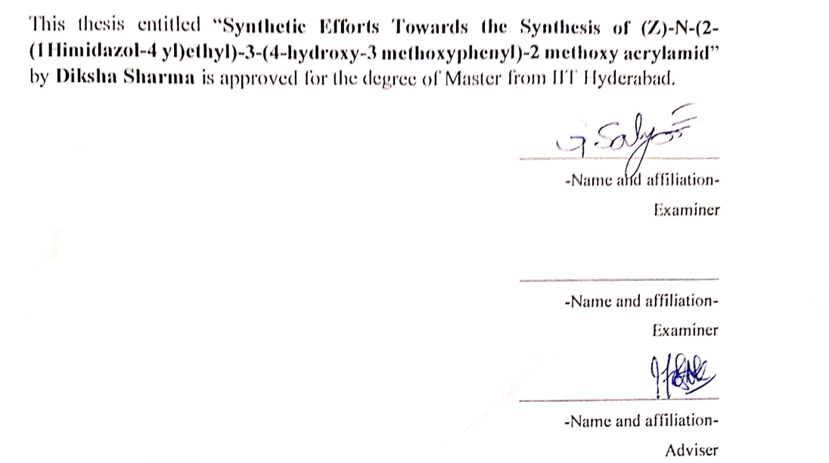

**DECLARATION**

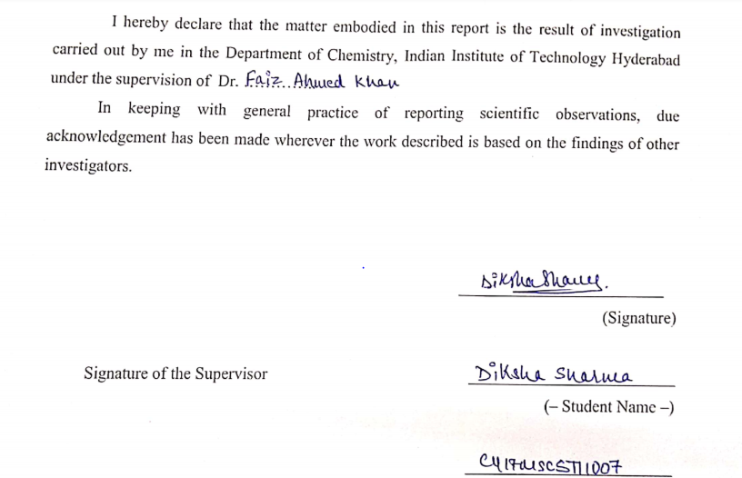

**ACKNOWLEGMENT**

Foremost, I would like to express my sincere gratitude to my research supervisor Dr. Faiz Ahmad Khan for his continuous support in my M.Sc. study and research, for his patience, motivation, enthusiasm and immense knowledge. His guidance helped me during research and writing of this thesis. Throughout, my whole M.Sc. he motivated me a lot towards my career.

I would like to thank the whole faculty of Chemistry department. My special thanks to Dr. M.Deepa whose generous and amiable nature has always helped me a lot in perfoeming well at academics in IIT hyderbad.

I would also like to thank my family.

**ABSTRACT**

One of the component of the venom of mexican scorpion Megacormus gertschi is alkaloid. Efforts are made towards the synthesis of that alkaloid component of the venom with commercially available vanillin as starting material. Efforts are made to synthesis it via wittig reaction where wittig salt and protected vanillin are formed successfully but failed to produce positive results of wittig reaction with different combination of bases and solvent.

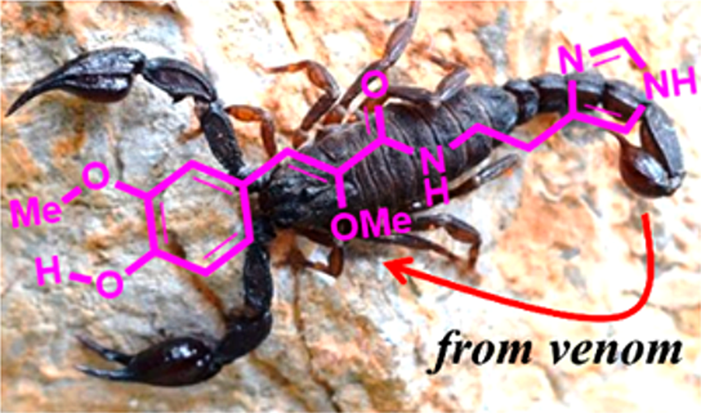

1. **INTRODUCTION**

On earth for nearly 400 million years, scorpions have constituted well adapted order of predatory animals. 1700 species are found to exist till date. They have occupied virtually every terrestrial habitat, except Antarctica. Due to immense increase of human civilization and population, interaction of humans with these arthropods have resulting in accidents. There are wide effects of the scorpion sting, from inflammation to severe clinical complications, including death.

Since the origin of ancient culture, scorpion venom have been used as medicine due to its anti-proliferative properties, it is considered to be a potential therapeutic agent.

Various research are been done on this venom to know whether it is formed by the scorpion to kill its prey or not. At the same time, few experiments are been done to analyse the origin of this venom. That is, the part of its body where the synthesis of this venom is taking place. Moreover, the exact role of this venom is not clear completely but further studies and researches might help us to understand properly about the formation and usage of this venom in the scorpion’s body.

Few experiments were done on mice to determine the extent of venomosity of this alkaloid component of the venom. But, results showed, neither it paralyzed nor it kill the mice. With this being a potential candidate for evaluating its medicinal effect, efforts are made to produce a low cost and economically effective method to synthesize the same.1



With NMR and HRMS the structure of the alkaloid is depicted and named as (Z)-N-(2-(1Himidazol-4-yl)ethyl)-3-(4-hydroxy-3-methoxyphenyl)-2 methoxy acrylamide.

This compound is the first ever alkaloid identified from a scorpion venom.1

The venom is observed to contain two pharmaceutically admired moieties; vanillin and histamine which are potential starting material of various important drugs.1

 

Another important feature seen in the structure of venom is its similarity with that of feruloylhistamine which is a great hypotensive agent.1

 

The only synthesis known for the venom is from vanillin as described in Scheme A.

Vanillin is treated with methyl-2-methoxy acetate in the presence of n- BuLi and diisopropylamine to form the condensation product. After condensation reaction, benzenesulfonyl chloride is added forming addition product 3 which is further treated with triethylamine to produce carboxylic ester 4. The ester is further hydrolyzed to give unsaturated acid. The acid obtained is reacted with commercially available histamine in the presence of DCC and TBOH to give the venom in 73%.1



**SCHEME A1 : Synthesis of alkaloid 1**

1. **RESULTS AND DISCUSSIONS**

The efforts are made to synthesis the target molecule started with the synthesis of wittig salt, taking dimethoxy methyl acetate as the starting material reacting with phosphorus chloride. The product is obtained in 58% yield via the formation of chloromethoxy methyl acetate. Initial attempts made towards wittig reaction was with vanillin and wittig salt in the presence of different bases, solvent and temperature (shown in table 2.1). But, unfortunately desired results were not obtained under any of the tried conditions.

|  |  |  |  |  |  |
| --- | --- | --- | --- | --- | --- |
| S.No. | Base | Solvent | Temperature | Time | Result |
| 1 | NEt3 | DCM | RT = 32 oC | 48 hours | No Reaction |
| 2 | DBU | DCM | RT = 36 oC | 48 hours | No Reaction |
| 3 | DBU | THF | RT = 36 oC | 48 hours | No Reaction |
| 4 | KtBuO | DCM | RT = 32 oC | 48 hours | No Reaction |
| 5 | NaOMe | MeOH | reflux | 48 hours | No Reaction |
| 6 | DBU | Toluene | reflux | 48 hours | No Reaction |

TABLE 2.1

Few successful attempts were made to increase the reactivity of vanillin by protecting its hydroxyl group. One such protection was done using tert-butyldimethylsilyl chloride in DMF, giving 84% yield. Another stratergy used for protection is with acetyl chloride, giving 88% yield. The protected vanillin was then reacted with same wittig salt, not giving the desired product (shown in Table 2.2)

|  |  |  |  |  |  |
| --- | --- | --- | --- | --- | --- |
| S.No. | Base | Solvent | Temperature | Time | Result |
| 1 | DBU | DCM | RT = 32 oC | 48 hours | No Reaction |
| 2 | DBU | DCM | RT = 36 oC | 48 hours | No Reaction |

TABLE 2.2

1. **CONCLUSION**

Efforts made towards total synthesis of venom via wittig reaction where wittig salt and protected vanillin are formed successfully but due to less reactivity of both vanillin and wittig salt, the expected compound is not obtained at different base, solvent and temperature.

**4) EXPERIMENTAL SECTION**

All manipulations of air-sensitive materials were performed with the rigorous exclusion of oxygen and moisture. Toluene was distilled under nitrogen from LiAlH4. Methanol was also dried under nitrogen from sodium and kept under molecular sieves prior to use. 1H NMR (400MHz) and 13C NMR (C100 MHz) spectra were recorded with a BRUKER AVANCE III-400 spectrometer. Elemental analysis were performed with a BRUKER EURO EA at Indian Institute of Technology Hyderabad.

1. **Synthesis of Wittig Salt3**

**4(a) – Preparation of intermediate of wittig Salt**

To an RB flask containing PCl5, A (1g, 7.4523mmol) is added dropwise as the reaction is highly exothermic or fuming. The reaction mixture was refluxed for 1.5 hours at 140 oC. When RB came to room temperature, reflux condenser was replaced by short path distillation condenser. Vacuum distillation started at 60 oC, no distillation was observed. So, the temperature was increased gradually to 85-90 oC where distillation started.



4(a) : Preparation of Methyl chloromethoxy acetate

**4(b) - Preparation of Wittig Salt**

To an RB containing distillate obtained after vacuum distillation is immediately treated with dichloromethane (4 mL) and triphenyl phosphine (1.9545g, 7.3750 mmol). The reaction mixture was stirred for 18 hours until a yellow colour solution is obsrrved. After DCM evaporation, ether washig was done which gave taffy (sticky) solid. The solid was kept under high vacuum for 24 hours giving light yellowish brown colour solid.



(b) – Preparation of wittig salt

1. **Wittig Reaction**

To an RB containing wittig salt ( 3.0 eq ) and solvent, base ( 3.5 eq ) is added and the reaction mixture is kept on stirring for 30 minutes at suitable temperature. After which, protected vanillin (1.0 eq ) is added to reaction mixture and the reaction is carried out for 48 hours at suitable temperature.



**2(a) –**

To an RB containing wittig salt ( 100 mg, 0.1245 mmol ) and dichloromethane ( 5 mL ) , triethylamine ( 14.28 mg, 0.1945 mmole ) is added and the reaction mixture is kept on stirring for 30 minutes at 0 oC. After which, vanillin ( 6.3 mg, 0.1650 mmol ) is added to reaction mixture and stirred for 48 hours at room temperature. The reaction mixture was monitored by TLC. The obtained reaction mixture is worked up using distilled water and dichloromethane. The organic layer obtained after separating is purified by column. The desired spot was isolated at 20 % ethyl acetate in hexane and characterized through NMR.



2(a)

**2(b) –**

To an RB containing wittig salt ( 70 mg, 0.1746 mmole ) and DCM ( 5 mL ) , DBU ( 28.164 mg, 0.1850 mmole ) is added and the reaction mixture is kept on stirring for 30 minutes at room temperature. After which, vanillin ( 17.710 mg, 0.1160 mmole ) is added to reaction mixture and stirred for 48 hours at room temperature. The reaction mixture was monitored by TLC. The obtained reaction mixture is worked up using distilled water and dichloromethane. The organic layer obtained after separating is purified by column. The desired spot was isolated at 20 % ethyl acetate in hexane and characterized through NMR.



2(b)

**2(c) –**

To an RB containing wittig salt ( 100 mg, 0.249 mmol ) and THF ( 7 mL ) , DBU ( 42.84 mg, 0.2819 mmol ) is added and the reaction mixture is kept on stirring for 30 minutes at 50 oC. After which, vanillin ( 56.93 mg, 0.3741 ) is added to reaction mixture and stirred for 48 hours at room temperature. The reaction mixture was monitored by TLC.



2(c)

**2(d) –**

To an RB containing wittig salt ( 100 mg, 0.2500 mmol ) and DCM ( 5 mL ) , potassium tert- butoxide ( 25.25 mg, 0.2656 mmol ) is added and the reaction mixture is kept on stirring for 30 minutes at room temperature. After which, vanillin ( 25.305 mg, 0.2660 mmol ) is added to reaction mixture and stirred for 48 hours at room temperature. The reaction mixture was monitored by TLC.



2(d)

**2(e) –**

To an RB containing wittig salt ( 100 mg, 0.2500 mmol ) and methanol ( 5 mL ) , sodium methoxide ( 14.5 mg, 0.2660 mmol ) is added and the reaction mixture is kept on stirring for 30 minutes at room temperature. After which, vanillin ( 25.305 mg, 0.1160 mmol ) is added to reaction mixture and refluxed for 48 hours. The reaction mixture was monitored by TLC.



2(e)

**2(f) –**

To an RB containing wittig salt ( 100 mg, 0.2500 mmol ) and toluene ( 5 mL ) , DBU ( 42.84 mg, 0.2819 mmol ) is added and the reaction mixture is kept on stirring for 30 minutes at room temperature. After which, vanillin ( 25.305 mg, 0.1160 mmol ) is added to reaction mixture and refluxed for 48 hours. The reaction mixture was monitored by TLC.



2(f)

**3 - Protection of Vanillin**

**3(a) - With TBS group4**

To an RB containing vanillin ( 0.5 g, 3.286 mmole ), DMF ( 6.5 mL ) and TBDSCl ( 0.75 g, 4.929 mmole ), imidazole ( 0.35 g, 5.257 mmole ) is added at 0 0C. The reaction micture was stirred for 2 hours at room temperature. The reaction mixture was monitored by TLC. The reaction mixture is worked up with water and ethyl acetate followed by brine. After drying it over sodium sulphate, it is purified through column where desired spot was isolated at 5 % ethyl acetate in hexane and characterized through NMR.



**3(a)**

**3(b) - With acetate group7**

To an RB containing vanillin ( 0.5 g, 3.286 mmol ), triethylamine ( 0.4323 g, 4.272 mmol )and dichloromethane ( 8.4 ml ), acetyl chloride ( 0.3353 g, 4.272 mmol ) is added at 0 OC and for 20 minutes. The completion of reaction is confirmed by TLC. After which the reaction mixture was filtered and obtained residue was washed with DCM. The resultant filtrate was further washed with water and brine followed by drying over sodium sulphate. Yellow colour solid is obtained and characterized by NMR.



**3(b)**

1. **Wittig Reaction with Protected Vanillin**

**4 (a) – With TBS protected vanillin**

To an RB containing wittig salt ( 226 mg, 0.5630 mmol ) and DCM ( 4 mL ) , DBU ( 99.96 mg, 0.6566 mmol ) is added and the reaction mixture is kept on stirring for 30 minutes at room temperature. After which, TBS protected vanillin ( 50 mg, 0.1876 mmol ) is added to reaction mixture and stirred for 48 hours at room temperature. The reaction mixture was monitored by TLC. After 2 days, again a mixture of wittig salt () , DCM () and DBU is added. The obtained reaction mixture is worked up using distilled water and dichloromethane. The organic layer obtained after separating is purified by column. The desired spot was isolated in pure hexane and characterized through NMR.



**4(a)**

**4 (b) – With acetate protected vanillin**

To an RB containing wittig salt ( 309.63 mg, 1.5449 mmol ) and DCM ( 5 mL ) , DBU ( 265.35 mg, 1.743 mmol ) is added and the reaction mixture is kept on stirring for 30 minutes at room temperature. After which, acetate protected vanillin ( 50 mg, 0.5149 mmol ) is added to reaction mixture and stirred for 48 hours at room temperature. The reaction mixture was monitored by TLC. After 2 days, again a mixture of wittig salt ( 309.63 mg, 1.5449 mmol ) , DCM ( 5 ml ) and DBU ( 265.35 mg, 1.743 mmol ) is added. The obtained reaction mixture is worked up using distilled water and dichloromethane. The organic layer obtained after separating is purified by column. The desired spot was isolated in pure hexane and characterized through NMR.



**4(b)**



**C**

(1,2-dimethoxy-2-oxoethyl)triphenylphosphonium chloride

Isolated yield (1584 mg, 53 %). 1HNMR (400 MHz,CDCl3): δH = 8.19 (d, 1H, CH) 3.80 (s, 3H, OCH3) 3.53 (s, 3H, OCH3) 7.91-7.41 (d, 5H, Ar*H*) 13C NMR (100 MHz DMSO-d6): δC = 167.10 (CH) 135.07-130.12 (Ar*H*) 62.5 (CO) 53.25 ( CO )ppm.



**3 (a)**

4-((tert-butyldimethylsilyl)oxy)-3-methoxybenzaldehyde

Isolated yield (733 mg, 84 %). 1HNMR (400 MHz,CDCl3): δH = 9.83 (s, 1H, CHO) 7.39-7.34 (d, 5H, Ar*H* ) 3.12 (s, 1H,OCH3) 0.98 (s, 9H, SiCH3) 0.18 (s, 6H, CH3  ) 13C NMR (100 MHz,CDCl3): δC =190.98 (CO) 151.63-151.33 (ArH) 55.43 (CH) 25.59 (CH) 18.50 (CH) ppm.

1. **REFERENCES**
2. Banerjee, S.; Gnanamani, E.; Lynch, S. R.; Zuñiga, F. Z.; Jimenez-Vargas, J. N.; Possani, L. D.; Zare, R. N. An Alkaloid from Scorpion Venom: Chemical Structure and Synthesis. *J. Nat. Prod.*, **2018**, *81,* 1899–1904.
3. Quéron,E.; Lett, R.; Synthetic studies on bafilomycin A1: stereoselective synthesis of the enantiopure C1–C11 fragment. *Tetrahedron Lett.*, **2004**, *45,* 4527–4531.
4. Crimmins, M. T.; Mans, M. C.; Rodríguez, A. D. Total Synthesis of the Proposed Structure of Briarellin J. *Org. Lett.*, **2010**, *12* , 5028–5031.
5. Shirai, T.; Kumihashi, K.; Sakasai, M.; Kusuoku, H.; Shibuya, Y.; Ohuchi, A. Identification of a Novel TRPM8 Agonist from Nutmeg. *ACS Med. Chem. Lett.*, **2017**, *8*, 715–719.
6. Seneci, P.; Leger, I.; Nadler, M. S. Total Synthesis of the Proposed Structure of Briarellin J. *Tetrahedron* , **1997**, *53*, 17097-17114.
7. Adepu, R .; Prasad, B.; Ashfaq, M. A. New MCR based on intramolecular Heck reaction under aerobic condition: A direct access to cytotoxic fused *N*-heterocycles. *RSC Adv.*, **2014**, *4*, 49324-49328.
8. Mastihubová, M.; Poláková, M.; Beilstein. A selective and mild glycosylation method of natural phenolic alcohol. *J. Org. Chem.* **2016**, *12,* 524–530.
9. Baker, G.H.; Brown, P. J.; Dorgan, R. J.; Everett, J. R.; Ley, S. V.; Slawin, A. M.; Williams, D. J. Antineoplastic agent 560: Isolation and structure. Tetrahedron Lett., **1987**, *28* , 5565-5568.
10. Evans, D. A.; Calter, M. A. *Tetrahedron Lett*., **1993**, *34* , 6871-6874.
11. Toshima, K.; Jyojima, T.; Yamaguchi, H.; Murase, H.; Yoshida, T.; Matsumura, S.; Nakata, M. Synthetic studies on concanamycin A. *Tetrahedron Lett*., 1996, *37* , 1069-1072.
12. Scheidt, K. A.; Tasaka, A.; Bannister, T. D.; Wendt, A. D.; Roush, W. R. Total synthesis of (-)Bafilomycin A1. Angew. Chem., Int. Ed., 1999, *38* , 1652-1655.
13. Eustache, F.; Dalko, P. I.; Cossy, J. Enantioselective monoreduction 2-alkyl-1,3-diketones mediated by chiral ruthenium catalyst. *Tetrahedron Lett.,* 2003, *44*, 8823-8826.
14. Toshima, K.; Jyojima, T.; Yamaguchi, H.; Murase, H.; Yoshida, T.; Matsumura, S.; Nakata, M. Synthetic studies on concanamycin A *J. Org. Chem*., 1997, *62* , 3271-3284.
15. Marshall, J. A.; Garofalo, A. W. Oxidative cleavage of mono, di and trisubstituted olefins to methyl ester through ozonolysis. *J. Org. Chem*., 1993, *58* , 3675-3680.
16. Paterson, I.; McLeod, M. D. Studies of macrolide synthesis. *Tetrahedron Lett.* 1997, *38*, 4183–4186.
17. Bach, K. K.; El-Seedi, H. R.; Jensen, H. M.; Nielsen, H. B.; Thomsen, I.; Torssell, K. B. G. 1,3-Dipolar cycloaddition of ethoxy carbonyl-nitrile benzyimine *Tetrahedron* 1994, *50*, 7543–7556.
18. Lee, J. K.; Banerjee, S.; Nam, H. G.; Zare, R. N. Q. Abiotic synthesis of purine and pyrimidine ribonucleosides in aqueous microdroplets. *Rev. Biophys*. 2015, *48*, 437-444.
19. Li, S.; Zhu, S.-F.; Xie, J.-H.; Song, S.; Zhang, C.-M.; Zhou, Q.-L. Well-defined chiral spiro iridium/phosphine-oxazoline cationic complexes for highly enantioselective hydrogenation of imines. *J. Am. Chem. Soc*. 2010, *132*, 1172-1179.
20. Misra, S. K.; Ye, M.; Kim, S.; Pan, D. A quinoxaline- fused tetrathiafulvalene- based sensitizer for efficient dye-sensitized solar cells*. Chem. Commun*. 2014, *50*, 13220-13223.
21. **SUPPORTING INFORMATION**

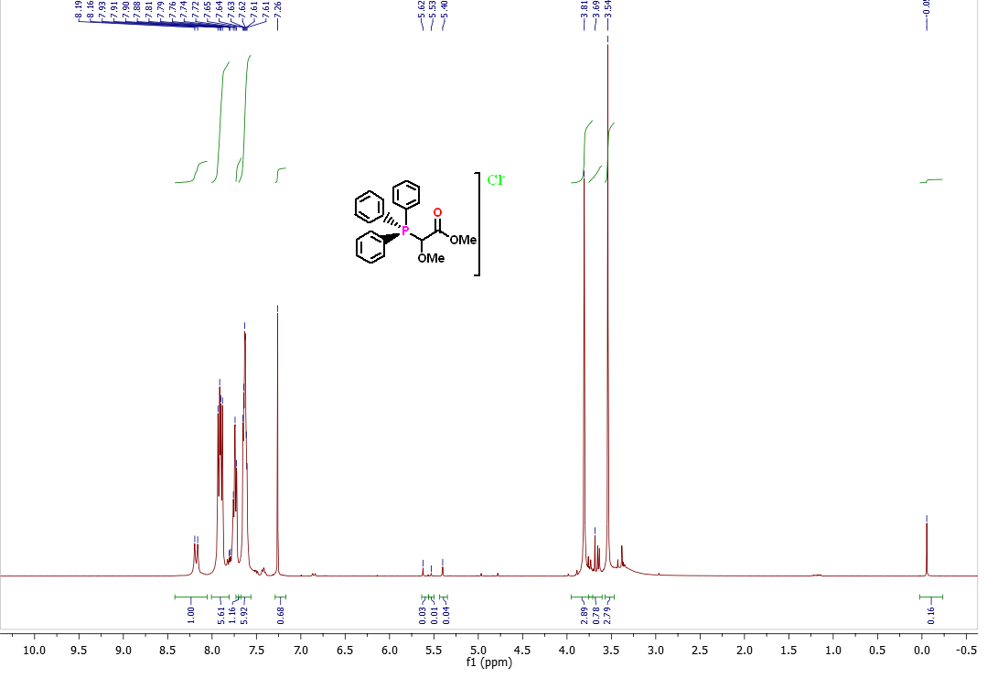

Fig : 1 1H NMR for compound C in CDCl3

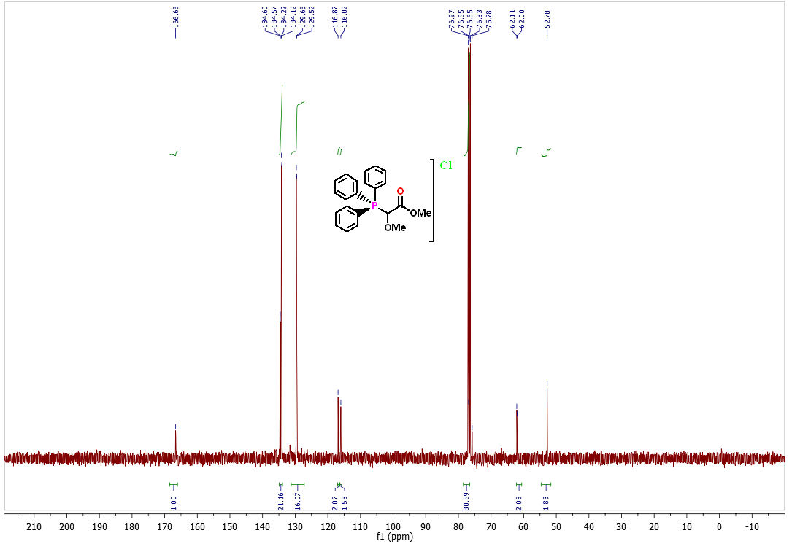

Fig : 2 13C NMR for compound C in CDCl3

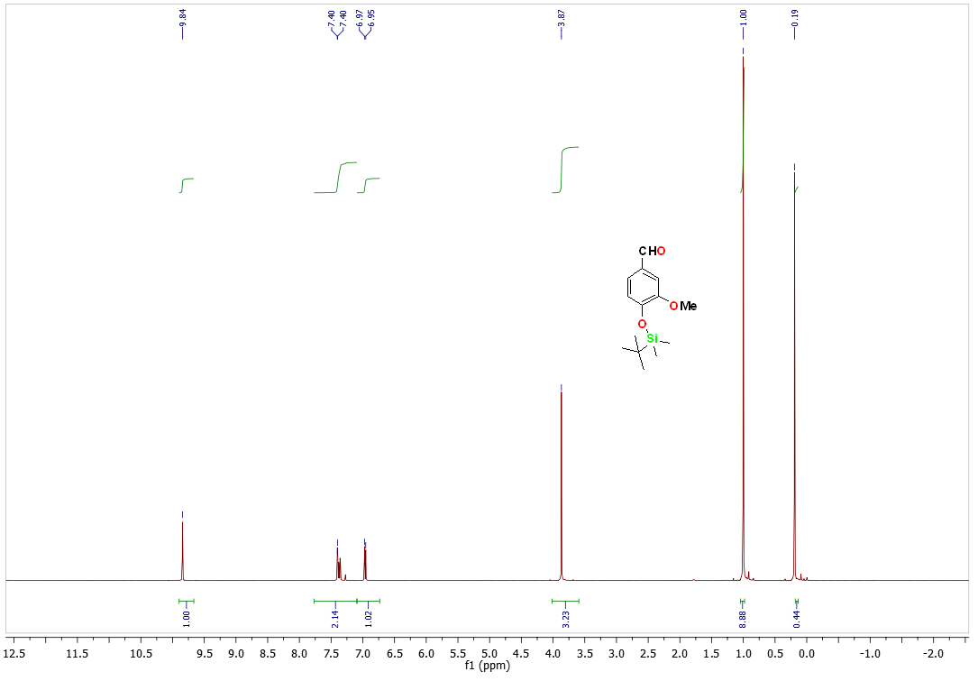

Fig : 3 1H NMR for compound 3 (b) in CDCl3

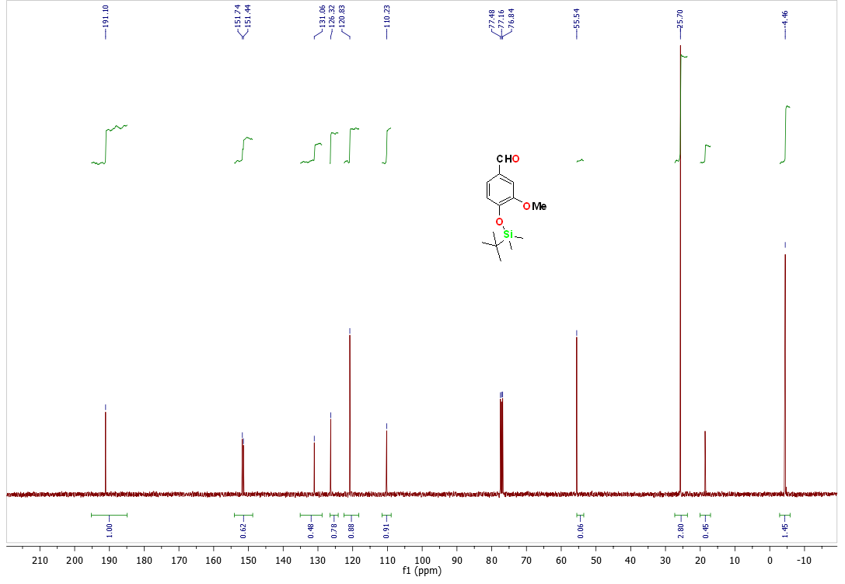

Fig : 4 13C NMR for compound 3(b) in CDCl3