N-Heterocyclic Carbene Supported Halosilylenes: New Frontiers in an Emerging Field♦
Nirmala Muthukumaran,‡, § Kavitha Velappan,¤, § Kritika Gour‡,§ and Ganesan Prabusankar*,‡,§
‡Department of Chemistry, Indian Institute of Technology Hyderabad, Kandi,
Sangareddy, Telangana, INDIA- 502285
¤Department of Chemistry, GITAM University, Rudraram, Patancheru, Hyderabad, Telangana-502329, INDIA

* Corresponding author
§ Equal Contribution
♦ Dedicated to Prof. Dr. Dr. h.c. mult. Herbert W. Roesky
E-mail address: prabu@iith.ac.in (Ganesan Prabusankar)

Contents
Abstract
Keywords
Abbreviations
1. Introduction
2. NHC stabilized halosilylenes (NHC)SiX₂
3. Reactivity of NHC bearing halosilylenes
3.1 Reactions of NHC:SiX₂ (X = Cl, Br, I, R) with S block and P block substrates
3.2 Reactions of NHC:SiX₂ (X = Cl , Br, I, R) with transition metal substrates
4. Bonding in NHC stabilized silylenes and their complexes
4.1. Type of carbene: NHC-silylene stabilized phosphinidenes vs cAAC-silylene stabilized phosphinidenes
4.2. Effect of substitution on silicon atom
5. Summary and outlook
6. Acknowledgement
7. References

Abstract
The isolation of a rare and highly unstable silicon(II) dihalide using N-heterocyclic carbene (NHC) proved to be a landmark achievement in the field of silicon chemistry. The first stable NHC stabilized halosilylene was isolated and structurally characterized in 2009. Subsequently the study of NHC stabilized halosilylenes over the past nine years has opened-up a new dimension in the field of organosilicon chemistry. NHC stabilized halosilylene compounds have been extensively used as starting materials for the synthesis of rare organosilicon compounds like small ring systems with high ring-strain energy containing silicon (silaoxirane), C4-silyl substituted NHC, Si-Si multiple bond, molecule with rare Si-M bond (M = main group or transition metals), dichlorosilamines (Si=N), silaisontriles, trisilaallenes (silicon analogue of allene) etc. These studies clearly demonstrated the potential applications of NHC stabilized halosilylenes in various fields of organosilicon chemistry. The present review summarizes the progress and scope of NHC-halosilylene chemistry. In particular, an overview of synthetic strategies, spectral properties, key structural features and available bonding analysis are discussed.
Keywords
Group-14 elements • Halosilylene • Low Valent Silicon • Main Group Chemistry • N-Heterocyclic Carbene • Silicon(II) • Transition Metal Chemistry
Abbreviations:
Ar = Aryl
Et = Ethyl
cAAC = cyclic alkyl(amino) carbene
Cp = η-cyclopentadienyl
Cp* = η-pentamethyl cyclopentadienyl
DFT = Density functional theory
diip = 2,6-diisopropylphenyl
EI-MS = Electron ionization mass spectrometry
HOMO = Highest occupied molecular orbital
h = hours
Im = Imidazol-2-ylidene
Idipp = N,N’-bis(2,6-diisopropylphenyl)imidazol-2-ylidene
IR = Infrared
IMe₄ = 1,3,4,5-tetramethylimidazolin-2-ylidene
IiPr = 1,3-diisopropyl-4,5-dimethylimidazol-2-ylidene
LUMO = Lowest unoccupied molecular orbital
NBO = Natural Bond Orbital.
NHC = N heterocyclic carbene
NMR = Nuclear magnetic resonance
iPr = Isopropyl
Me = Methyl
Mes = Mesityl
Mes* = 2,4,6-tritertiarybutylphenyl
Ph = Phenyl
RT = Room temperature
SIdipp=1,3-bis[2,6-bis(isopropyl)phenyl]imidazolidin-2-ylidene
tBu = tert-butyl
Tbb=2,6-(CH(SiMe₃)₂)₂-4-tBu phenyl or 4-tbutyl-2,6-bis(bis(trimethylsilyl)methyl)phenyl
THF = Tetrahydrofuran
TMS = Trimethylsilane
TpMe = κ3-N,N′,Nʺ-hydridotris(3,5-dimethyl-1-pyrazolyl)-borate
Triip = 2,6-bis(2,6-diisopropylphenyl)phenyl
Trip = 2,4,6-triisopropylphenyl
UV-vis = Ultraviolet visible

1. Introduction
Highly reactive low valent silicon species are rare and such type of molecules are in high demand for the technological development. At this juncture, low-valent silicon chemistry has witnessed a renaissance area of research, experiencing continuous diversification. For example, two decades ago silylene was thought to be unstable at room temperature; however, today silylenes are “bottleable”. Numerous properties and characteristics of silylene have been measured and calculated (Chart 1). Silylenes are molecules that have a divalent neutral silicon(II) atom having lone pair of electrons (R₂Si:). Silylenes are key intermediates in various photochemical, thermal, and metal reduction reactions of organosilicon compounds []. Silylenes and its derivatives are generally highly reactive and were observed only in the gas-phase, in diluted solutions, and in frozen rare-gas matrices at low temperatures [–]. However, most of the silylenes are extremely unstable, decomposes or polymerizes rapidly above 77 K or reacts rapidly with solvents [,]. The realm of silylene chemistry has been expanded dramatically, and the investigation of reactivity of NHC stablilized silylene has had a profound influence in advancing modern inorganic chemistry.
The analogues of silylenes viz., carbenes, stannylenes and germylenes are well-known ‘di-coordinate divalent’ species [–]. With the advent in the field of carbene chemistry, in 1991, Arduengo and co-workers reported the synthesis and isolation of the first room-temperature stable crystalline carbene, imidazol-2-ylidene 1 (E = C, R = 1-adamantyl) []. Since this benchmark discovery, the chemistry of stable carbenes began its journey through a new way of developing the metallylenes to a large figure, and nowadays they are routinely used in synthesis, catalysis, and to stabilize unusual molecules [–]. More recently, stannylenes and germylenes were synthesized and characterized [7–9]. The preparation of these surprising compounds left silicon as the only element of group 14 with no di-coordinate divalent compound stable under ambient temperature. In fact, the isolation of related silicon compound is one of the most challenging task in organosilicon chemistry. Specific electronic and steric requirements are essential to stabilize these elusive and often ephemeral species. This situation has been changed when West et al., reported the first N-heterocyclic silylene that is stable at room temperature using N-donor ligand in 1994 [], which is comparable to the NHC [10]. Since then, stable silylenes have emerged as versatile building blocks for the synthesis of novel organosilicon compounds.
Chart 1. NHC stabilized halosilylenes
Among silylenes, halosilylenes were generated in the gas phase through thermolysis reactions and recognized with the aid of trapping reactions [–] or detected spectroscopically as transient species []. Compared to monochlorosilylene [], the isolation of dihalosilylenes are most challenging. Schmeisser [] and Schenk [] studied the condensation of dichlorosilylene to polymeric (SiCl₂)_{n} at room temperature. Occasionally halosilylenes exist as intermediates in condensed phases []. Since the first report of the stable divalent silicon species, Cp*₂Si: (Cp* = Me₅C₅, silicocene), by Jutzi and co-workers [–], a remarkable class of stable silylenes such as dialkyl silylene [] and cyclic silylenes were synthesized and characterized [17, –]. In 2009, the research groups of Roesky [] and Filippou [a] showed that the NHC can stabilize dihalosilylenes [NHC(SiX₂)] (X = Cl, Br) to form stable NHC:→SiX₂ complexes (Chart 1). The carbene center donates its lone pair of electron and binds strongly with silicon in low oxidation state []. As shown in the chart 1, [Si(:)X₂] species is electronically stabilized by NHC group and sterically protected by the attached bulky group. However, under specific reaction conditions the bond formed is facile enough to break for the use of free [Si(:)X₂] specious []. The thermal stability and the crystalline nature of the NHC-dihalosilylene adduct depends on the NHC and silicon halide used. Interestingly, [NHC(SiX₂)] can act as electron donor to transition metals and main group elements [a]. In particular, the Si(II) compounds [(Idipp)SiX₂] (Idipp = 1,3-bis(2,6-diisopropylphenyl)imidazolin-2-ylidene) and Si(Cl)R(IMe₄) (IMe₄ = 1,3,4,5-tetramethylimidazolin-2-ylidene) proved to be promising building blocks, which enabled the synthesis of new classes of unsaturated silicon compounds, including zwitterionic silylidene complexes, silylidyne complexes, metallosilylenes, and metallosilanones []. Besides, the chemistry of other low valent silicon NHC adducts, such as Si₂ [] silanones [] and [Si(Cl)R] [] are under developing stage.
In the singlet ground state, silylenes are divalent neutral silicon species with the lone pair of electrons as the HOMO and a vacant p orbital as the LUMO. Hence, depending on the substituents these molecules can behave as Lewis acids as well as Lewis bases (Chart 2). The silicon-carbon bond in [NHC(SiX₂)] considered to be a strong C→Si donor-acceptor single bond through donation of the carbene carbon lone pair into the vacant silicon p orbital of SiX₂ [34,35]. Therefore the Si–C bond is shorter than that of the silylene-carbene adduct [LʺSiCLʺ)] (Si–C=2.162(5) Å; Lʺ=1,2-(NCH₂tBu)₂C₆H₄) [37b], but longer than the Si=C bonds of the silenes [(Me₃Si)₂Si=C(OSiMe₃)Ad] (1.764(3) Å; Ad=1-adamantyl) [37c] and [Me₂Si=C(SiMe₃)SiMetBu₂] (1.702(5) Å) [37d]. As shown in chart 2, the carbon atom in [NHC(SiX₂)] is in an almost planar environment, while silicon center is distinctly trigonal pyramidal with stereochemically active lone pair of electron on silicon [34,35]. Hence it is clear that the Si-C bond length is more than a double bond and less than a single bond. However, it remains uncertain whether there is a possible back donation or not as this bonding situation strongly depends on the nature of NHC. As a result, we have noticed the inconsistency in the nature of Si-C bonding situation because it has been described with “dative bond arrows” or “one single conventional bond”. Therefore we would like to draw the attention to researchers to follow the most brilliant independent investigations on main group complexes with donor-acceptor bond by Frenking et al. and Krossing et al., while emphasizing the bonding situation in NHC stabilized halosilylene chemistry [37e-37g]. Therefore, the most appropriate bonding situation between C-Si or Si-M has been mentioned in this review.

Chart 2. Bonding picture in NHC stabilized halosilylenes

The major part of NHC main-group element chemistry was reviewed by Cowley et al., in 2000 [], followed by Kuhn et al., in 2005 [], Willans et al., in 2010 [], Bertrand et al., in 2013 [], Prabusankar et al., in 2014 [16b] and Frenking et al., in 2017 []. Besides, some of the exciting examples of low valent silicon NHC derivatives have been highlighted in the review of Robinson et al., in 2011 and 2012 [,], Roesky et al., in 2013 [] and Ishida et al., and Iwamoto et al., in 2016 []. However, the chemistry of [(NHC)SiX₂] has not been accounted so far. To the best of our knowledge, no survey has covered the synthetic, structural and reactivity features of the NHC bearing halosilylene derivatives. The only review appeared in similar research area is on chemistry of Si(II)F₂ (published on 10th April 2018), while reviewing the present review [51]. In this review, we present the recent advances and synthetic challenges in the chemistry of NHC supported halosilylene derivatives. The classification of the compounds was made by taking only the reactivity into account to cover all the literature published till June 2018. The known NHC-SiX₂ compound and their structural parameters are summarized in tabular form to provide the reader with a clear, helpful overview of the content.
2. NHC stabilized halosilylenes (NHC)SiX₂
SiX₂ are used in the chemical transport of silicon in many reactions. So, attempts were made to isolate monomeric silicon dihalide or its equivalent that can be handled at room temperature. Thus the isolation of halosilylenes became a challenge. Strong σ-donor and weak π-acceptor properties of NHCs have been exploited in the recent years to stabilize the compounds with main group elements in low oxidation states [48,]. NHC as a successful ligand in silicon chemistry was first demonstrated by Kuhn et al. [].
In 2008, Robinson et al., reported the synthesis of NHC stabilized bis-silylene (Si→ +1 oxidation state) using L¹SiCl₄ (L¹ = 1,3-bis(2,6-diisopropylphenyl)imidazole-2-ylidene). L¹SiCl₄ on reduction with potassium graphite (KC₈) in 1:6 molar ratio in hexane gives air sensitive orange-red, sheet like crystals of L¹ClSi–SiClL¹ (1) with 6.1% yield (Scheme 1 and Figure 1) [39]. The ¹H NMR of imidazole ring resonates at δ = 6.31. ²⁹Si{¹H} NMR peak was residing at δ = 38.4 in C₆D₆. The molecular structures of the complex were determined by single-crystal X-ray diffraction analyses. It can be seen that (Cl)Si–Si(Cl) core is sterically well shielded by 1,3-bis(2,6-diisopropylphenyl)imidazole-2-ylidene ligand. The silicon center adopts a three-coordinated trigonal pyramidal geometry with a substantial contribution from the lone pair of electrons and the two ligands 1,3-bis(2,6-diisopropylphenyl)imidazole-2-ylidene ligand and chloride ligand. The Si–Si bond distance is 2.393(3) Å which is only 0.03 Å longer than the usual Si–Si single bond. The Si–C bond distance (average) is 1.934(6) Å and Si–Cl bond distance is 2.164(3) Å comparable to the sum of covalent radii of Si and Cl (2.16 Å).
Scheme 1. Synthesis of L¹ClSi-SiClL¹ (1) [39]
The first base stabilized dichlorosilylene L¹SiCl₂ (2) (L¹=1,3-bis(2,6-diisopropylphenyl)imidazol-2-ylidene), which is stable at room temperature was reported by Roesky and his group in 2009. L¹SiCl₂ (2) was synthesized by the reaction of trichlorosilane with NHC (L¹) in 79% yield under mild reaction condition via the reductive elimination of HCl from trichlorosilane (Scheme 2 and Figure 1) [33]. A multistep procedure was also developed to prepare L¹SiCl₂ (2) using L¹SiCl₄ [33] and two equivalents of potassium graphite in toluene (Scheme 3). Compound 2 was obtained as colorless crystal with a yield of 48%. Similarly, reduction of L²SiCl₄ (L²=1,3-bis(2,4,6-trimethylphenyl)imidazol-2-ylidene) with KC₈ afforded the dichlorosilylene L²SiCl₂ (3) as pale yellow solid in moderate yield from a 2:1 mixture of toluene and n-hexane [33]. Compounds L¹SiCl₂ (2) and L²SiCl₂ (3) are stable at room temperature under inert atmosphere and are soluble in toluene and THF. The ²⁹Si NMR of L¹SiCl₂ (2) and L²SiCl₂ (3) have signals at δ = 19.06 and 17.84, respectively. The molecular structure of L¹SiCl₂ (2) was determined by single-crystal X-ray diffraction analysis, which revealed that the complex possesses a trigonal pyramidal geometry at the threefold-coordinated silicon atom, with the stereochemically active lone pair at the apex. The molecular simulation of 2 by DFT Turbomole at BP/TZVP gave the angles between LP_{Si}–Si–C(carbene), LP_{Si}–Si–Cl(in-plane) and LP_{Si}–Si–Cl(orthogonal) are 114.408, 121.938 and 123.378, respectively (LP_{Si} ; lone pair density).
Scheme 2. Synthesis of L¹SiCl₂ (2) [33]

Scheme 3. Synthesis of L¹SiCl₂ (2) and L²SiCl₂ (3) [33]
The first stable carbene adduct of dibromosilylene - L¹SiBr₂ (4) was synthesized by Filippou et al., in 2009 (Scheme 4 and Figure 1) [34a]. The synthesis of L¹SiBr₂ (4) was done in two steps: in the first step, SiBr₄ was treated with one equivalent of the L¹ to yield the ionic product [L¹SiBr₃]⁺Br⁻ as a white solid in high yield and in the second step, reduction of [L¹SiBr₃]⁺Br⁻ with 2.5 equivalents of potassium graphite (KC₈) in THF at ambient temperature yielded the L¹SiBr₂ (4) in 48% yield as a yellow, air-sensitive solid. It is stable under rigorous exclusion of air in benzene solution at ambient temperature for a period of about a week. Structures of the compound have been determined by single-crystal X-ray diffraction analyses. The crystal structure of 4 shows that the dibromosilylene – carbene adduct is composed of monomers with short Si-C bond. The carbon atom is in almost planar environment (sum of angles at C1=358.98º, fold angle at C1 = 9.0(2)8º), whereas the silicon center is distinctly trigonal pyramidal (sum of angles at Si = 292.78º, fold angle at Si=78.2(1)8º) indicating the presence of a stereochemically active lone pair of electrons on silicon. These bonding parameters indicate the presence of a rather strong C→Si donor–acceptor single bond in (4) resulting from the donation of the carbene carbon lone pair into the vacant silicon p orbital of SiBr₂, which is in full agreement with the results of the quantum chemical calculations. Similarly L′SiBr₂ (L′=1,3-bis[2,6-bis(isopropyl)phenyl]imidazolidin-2-ylidene) (4a) was synthesized in a two-step procedure, in the first step SiBr₄ was treated with L′ to yield [L′SiBr₃]⁺Br⁻ which upon reduction with 2.35 equivalents of KC₈ yielded L′SiBr₂ as yellow crystalline solid in 77% yield which was characterized by ¹³C, ²⁹Si NMR and X-ray diffraction techniques. The compound is very air-sensitive and decomposed when heated to 191-192 °C. The ligand L′ can be synthesized by the method employed by Aurdengo et al. [34b].
Scheme 4. Synthesis of L¹SiBr₂ (4) and L′SiBr₂ (4a) [34]
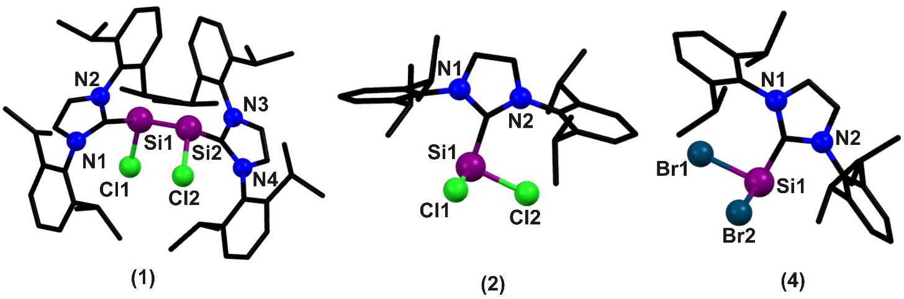Fig. 1.
Filippou et al., have synthesized the first NHC adducts of arylchlorosilylenes which are compared to the homologous germanium compounds (Scheme 5) [41a]. The arylsilicon (II) chlorides SiArCl(Im-Me₄) [Ar=C₆H₃-2,6-Mes₂ (Mes=C₆H₂-2,4,6-Me₃), (5); C₆H₃-2,6-Trip₂(Trip=C₆H₂-2,4,6-iPr₃) (6)] were obtained selectively on dehydrochlorination of the arylchlorosilanes SiArHCl₂ with 1,3,4,5-tetramethylimidazol-2-ylidene (Im-Me₄) which were isolated as analytically pure air-sensitive yellow solids in 72% and 93% yield respectively (Figure 2). The synthesized compounds were fully characterized. With vigorous exclusion of air, 6 is stable for at least 120 h in solution in benzene at ambient temperature, whereas 5 shows the first signs of decomposition within 24 h. The ¹³C NMR peaks are at δ = 165.2 for 5 and δ = 166.7 for 6. For aryl C, the value is δ = 150.6 for both. The ²⁹Si{¹H} NMR of 5 is at δ = 1.34 and 6 is at δ = 0.77. The crystal structure analysis of 5 indicates the presence of a distorted octahedral geometry with sum of all angle to be 357.9°. Si–C_{carbene} bond distance is 1.963(2) Å and Si–C_{Ar} bond distance is 1.937(2) Å. Also, Si–Cl bond distance is 2.1836(8) Å which is comparable to 2.
Scheme 5. Synthesis of SiArCl(ImMe₄) (5 & 6) [41a]
In 2011, Cui et al., reported the synthesis of first donor stabilized aminochlorosilylene (7) (Figure 2). 7 was synthesized by the reaction of aminochlorosilane, RSiHCl₂ and dilsilane with 2 equivalents of 1,3-bis(isopropyl)-imidazol-2-ylidene in presence of THF with 78% yield (Scheme 6) [41b]. Compound 7 was obtained as yellow powder and was characterized by ¹H, ¹³C and ²⁹Si NMR spectroscopy, single crystal X-ray diffraction analysis and elemental analysis. The resonance for the Si(II) atom in the ²⁹Si NMR spectrum of 7 was found at δ = 3.14, which is slightly downfield shifted compared to those observed for the NHC-stabilized arylchlorosilylenes (δ = 0.77 to δ = 1.34) that have been previously reported. The ¹³C-NMR signal for the NHC central carbon atom in 7 resonating at δ = 164.08 is consistent with those found in the NHC→Si donor-acceptor complexes. The molecular structure of 7 features the trigonal-pyramidal three-coordinate silicon atom (the sum of angles at the Si1 atom = 305.22°). The Si1–C20 bond length (2.002(19) Å) is slightly longer than those reported for NHC stabilized dihalosilylenes (1.985(4) and 1.989(3) Å).
Scheme 6. Synthesis of NHC stabilized aminochlorosilylene (7) [41b].
Biradicals are most thought-provoking moieties for the forthcoming investigations because of their high reactivity and most promising properties. The stable biradicals from singlet silylene precursors stabilized by NHCs has been reported by Roesky et al., in 2013 (Scheme 7) [,]. L⁴:SiCl₂ (8) was prepared from the reaction of L¹:SiCl₂, NHC (L¹:= :C[N(2,6-iPr₂C₆H₃)CH]₂) and HSiCl₃, with L⁴: (L⁴:=:C-(CH₂)(CMe₂)₂N-2,6-iPr₂C₆H₃) in THF to give dark-blue L⁴:SiCl₂ (8) in good yield (Scheme 7). It is an exothermic reaction. Whereas L⁵ is the by-product formed as prism like crystal due to the slow reaction between free L¹: and L⁴:SiCl_{2.} The compound L⁴:SiCl₂ (8) could be isolated as two polymorphs (I and II) depending upon the crystallization conditions (Figure 2). Both the polymorphs have almost identical geometries, the only difference is the size of the unit cell. Polymorph II was formed at 0 °C or RT in 2-3 days in the mother liquor as dark blue block crystals and is stable when exposed to air for a period of about one week (powdered form for 2-3 days) and do not decompose at room temperature in inert atmosphere for about 3–4 months. It melts at 179–181 °C and decomposes at 185–186 °C. Polymorph I crystallized as lighter blue block crystals at 0 °C in 1-2 weeks in the mother liquor and is stable in the mother liquor in inert condition for a few weeks and decomposes soon in 2-3 days to colorless crystals (solid form do not decompose in refrigerator at 0 to -32 °C). It melts at 167-168 °C and decomposes at 172–173 °C. X-ray diffraction studies of 8 showed that the geometry is distorted tetrahedral and the bond angle of carbene C-Si-C amplifies to 122.99(7)° due to steric factors. The ²⁹Si NMR signal at δ = 4.13 (in dilute solution only; δ = 19.06 for 2) shows intermolecular forces are quenching the NMR resonance and indicates the radical nature of the compound.
Scheme 7. Synthesis of L⁴₂SiCl₂ (8) [53,54].
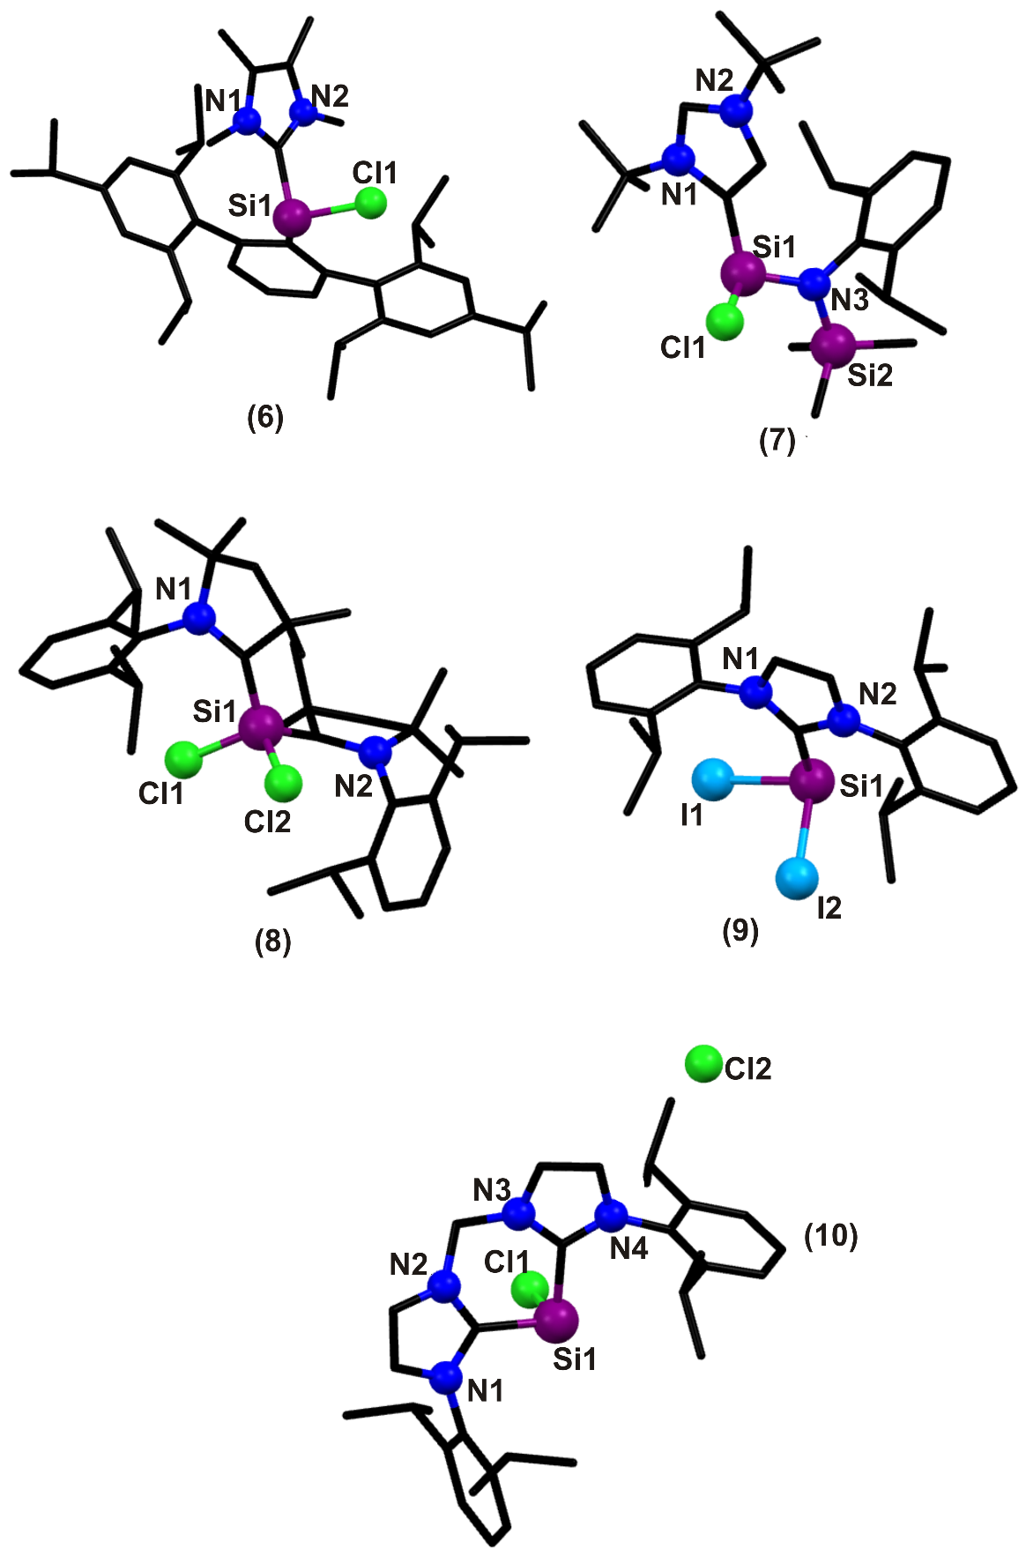
Fig. 2.
The synthesis of first NHC stabilized diiodosilylene was reported by Filippou et al., in 2013 which one was similar to the synthesis of 4. SiI₄ is treated with L¹ in benzene at 20 °C to make [SiI₃(IPr)]⁺I⁻, which on further treatment with 2.3 equivalents of KC₈, in benzene at 20 °C gives 9 as a yellow powder with ~81% yield (Scheme 8) []. 9 is stable in benzene and toluene at ambient temperature for many days and decomposes in solid state when heated above 160 °C. X-ray diffraction analysis showed that the structure of 9 is similar to that of its Cl and Br analogues and has trigonal pyramidal coordinated silicon centre showing the presence of stereochemically active lone pair (Figure 2). The Si-I bond length is 2.575(3) Å which is longer than that in the SiI₄ (2.432(5) Å). The Si–C (carbene) bond length is 1.984(7) Å which is similar for Si1 (1.989(3) Å) and Si2 (1.985(4) Å). Also, the bond energies for 9 (121.4 kJ/mol), 2 (121.4 kJ/mol) and 4 (123.6 kJ/mol) shows relatively stronger donor acceptor bond. The ²⁹Si{¹H}-NMR are δ = -9.7 for 9, δ = 10.9 for 4 and δ = 19.06 for 2 displays the same ²⁹Si nucleus deshielding upon halide substitution (I→Br→Cl).
Scheme 8. Synthesis of L¹SiI₂ (9) [55]
In the same year, Driess et al., synthesized bis NHC stabilized silylones. The silylone ([L⁶SiCl]⁺Cl⁻) (10) has been synthesized from the reaction of bis NHC ligand with NHC-SiCl₂ in the presence of THF with a yield 57% (Scheme 9) []. Compound 10 is insoluble in THF, but soluble in acetonitrile. The molecular structure of the complex was confirmed by single crystal X-ray diffraction studies (Figure 2). The silicon center of the silyliumylidene cation is three-coordinate - the two carbene carbons of the chelating ligand and the chlorine resulting in a trigonal planar geometry. The counter anion Cl⁻ is separated with the smallest distance of 6.424(2) Å from the silicon center. Due to chelation, the Si atom adopts a puckered six-membered C₃N₂Si ring with boat conformation and hence the three-coordinate Si^{II} atom in [L⁶SiCl]⁺Cl⁻ exhibits a drastic upfield shift in the ²⁹Si NMR spectrum at δ = -58.4 in CD₃CN showing much stronger electron donation effect by chelating bis NHC ligand. The Si–C bond distance is 1.961(4) Å.
Scheme 9. Synthesis of L⁶SiCl₂ (10) [56]
1,2-dihaloethanes 1,2-C₂H₄X₂ (X = Cl, Br, I) have proven to be particularly suitable reagents to accomplish the halogenation of the Si–Si double bond of the disilicon(0) compound (Idipp)Si]Si(Idipp) (L) in presence of THF or toluene at low temperature to selectively afford the Si(I) halides (X = Cl (11), Br (12), I (13)) in moderate to very good yields (11: 49%; 12: 98%; 13: 61%) (Scheme 10) []. Halogenation of L is a diastereoselective reaction leading exclusively to a racemic mixture of the RR and SS enantiomers of 11, 12 and 13. The silicon(I) halides (11, 12 and 13) were isolated as vermillion, extremely air-sensitive solids, which immediately decolorized when exposed to air, but can be stored indefinitely at room temperature under argon atmosphere. Compounds 12 and 13 are thermally quite robust in the solid-state and decompose upon heating at a temperature of 190 °C similar to that previously reported for 11 (184 °C). However, in the presence of toluene 12 starts to decompose at a much lower temperature (at 85 °C, ca. 10 % decomposition within 2 h), and the decomposition leads to Idipp, SiBr₂(Idipp) and an unknown toluene insoluble solid. Compound 12 was characterized by single crystal X-ray diffraction, multinuclear NMR spectroscopy and quantum chemical methods. The halogen substituents of 11, 12 and 13 adopt a synclinal conformation and the sterically more demanding Idipp groups adopt an antiperiplanar conformation (Figure 3). The Si–Br bond length in 12 is 2.3602(8)/ 2.3677(9) Å, C–Si bond length is 1.940(3) Å and Si–Si bond length is 2.385(1) Å. In ²⁹Si{¹H} NMR spectra, the Si(I) halides display a characteristic singlet signal (11: δ = 38.4, 12: δ = 34.9, 13: δ = 18.7), which appears in the low field. The ¹H and ^{13C}{¹H} NMR spectra of 12 and 13 display a set of signals for the homotopic Idipp groups originating from the time-averaged C2-symmetry of the RR/SS stereoisomers (the C2 axis perpendicularly intersects the Si–Si bond). The stereogenic Si centers, gives two different sets of ¹H/¹³C NMR signals for the ortho- and meta- positioned groups, respectively.

Scheme 10. Synthesis of the Si(I) halides (X = Cl (11), Br (12), I (13)) and further oxidation to the Si(II) halides SiX₂(Idipp) [57]
Li. et. al., described the trapping of a silicon(I) radical with NHCs by the reaction of the cyclic (alkyl)-(amino) carbene [cAAC_{Me}] (cAAC_{Me}= :C(CMe₂)₂(CH₂)NAr,Ar=2,6-iPr₂C₆H₃) with H₂SiI₂ in a 3:1 molar ratio in DME. This reaction absolutely lead to a mixture of the separated ion pair [(cAAC_{Me})₂Si:C]⁺I⁻(1), which features a cationic cAAC-silicon(I) radical, and [cAAC_{Me}-H]⁺I⁻ (Scheme 11) []. In addition, the same experiment was carried out in diethylether medium which afforded a mixture of crystals of 14 (a few pieces of crystals), [cAAC_{Me}-H]⁺I⁻ (major product),and [cAACMe=Si(I)]₂ (major product, 22% yield) []. These results demonstrated that 14 was formed in Et₂O, but is unstable and dimerizes to form [cAAC_{Me}=Si(I)]₂ (15). The X-ray diffractional studies of 14 revealed that the Si1 atom adopts a bent geometry, and is surrounded by C1and C21 atoms of cAAC_{Me} (Figure 3). The Si1 atom lies on the same plane as the N1–C1–C2 skeleton. C1–Si1–C21 bond angle lies in the range (122.96(15)8)°, which is significantly wider than that of the cAAC–silicon(0) complex[(cAAC_{Me})₂Si] (117.70(8)8).[3] The two C–Si1 bonds do not have the same lengths (C1–Si1 1.896(4) Å, C21–Si1 1.867(3) Å) but both are slightly longer than the donor–acceptor Si–C double bonds in [(cAAC_{Me})₂Si] (1.8411(18), 1.8417(17) Å) [].
Scheme 11. Synthesis of 14 and 15 [58].
NHC-substituted chlorosilylene (16) was synthesized by the reaction of silanorbornadiene with 1,3,4,5-tetramethylimidazol-2-ylidene in C₆D₆ (Scheme 12) []. The formation of compound 16 was confirmed by NMR spectroscopy, which compares well with the literature data [41a]. Based on the above reaction conditions, decomposition of the chlorosilylene 16 is already a significant follow-up process and prevented its isolation before complete consumption of the starting material.
Scheme 12. Reaction of silanorbornadiene with 1,3,4,5- tetramethylimidazol-2-ylidene to give NHC-substituted chlorosilylene 16 [61].
The cyclic alkyl(amino) carbene (cAAC) L₄ reacted with SiI₄ in toluene, affording the cAAC-silicon tetraiodide complex [(cAAC_{Me})SiI₄] (17), cAAC_{Me}= :C(CH₂)(CMe₂)₂NAr, Ar = 2,6-iPr₂C₆H₃). It further reacted with two equivalents of KC₈ in toluene at room temperature to afford the first cAAC-diiodosilylene [(cAACMe)SiI₂] (18) (Scheme 13 and Figure 3) []. 18 was isolated as red crystalline solid with a yield of 56 %. Theoretical calculations show that the C_{carbene}−Si bond in 18 is formed by the donation of the lone pair of electrons on the C_{carbene} atom to the SiI₂ moiety, while the π-back-bonding of the lone pair of electrons on the Si atom to the C_{carbene} atom is negligible. The compound 18 was stable under inert atmosphere for two months, during which a slow decomposition to a white powder was observed. And it is soluble and stable in non-polar solvents such as benzene and toluene for 3 weeks, but decay fast in THF. The ¹H NMR spectrum shows one set of signals due to the cAAC_{Me} backbone. In¹³C NMR the C_{carbene} atom resonating at  = 230.1. The ²⁹Si NMR spectrum of 18 displays a singlet at δ = -2.1. The molecular structure of 18 was established by single crystal X-ray diffraction studies. The Si1 atom adopts a distorted trigonal pyramidal geometry, indicating a stereochemically active lone pair of electrons on the Si center. The sum of the bond angles at the Si atom is 299.66° and it is comparable to those of the NHC-dihalosilylene complexes [(IAr)SiX2] (X = Cl: 289.7°; Br: 292.7°; I: 297°) [33,34,55]. The C1−Si1 bond in 18 is 2.013(5) Å which is significantly longer than that in some of the cAAC-Si complexes (1.82 Å – 1.88 Å). In compound 18 there is synergic electron transfer between the C_{carbene} and Si atoms: the σ-donation of electrons from the C_{carbene} atom to the vacant orbital of the Si atom along with the π-back-donation of electrons on the Si center to the vacant p-orbital on the Ccarbene atom. The C1−Si1 bond in 18 is longer than those of the NHC-silylene complexes such as [(IAr)SiX₂] (1.989(3)−1.984(7) Å; X = Cl,Br, I), [(IMe)Si(SitBu₃)₂] (1.933(4) Å, IMe = :C{N(Me)-CMe}₂), and [(IMe)SiAr*Cl] [1.963(2) Å, Ar* = C₆H₃-2,6-Trip₂, Trip = C₆H₂-2,4,6-iPr₃]. Moreover, the C1−N1 bond of 18 (1.301(6) Å) is almost identical to that of the cAAC – tetrachlorosilane complex [(cAACMe)SiCl₄] (1.304(2) Å). These results illustrate that the C1−Si1 bond in 18 is a donor−acceptor single bond.
Scheme 13. Synthesis of 17 and 18 [62].
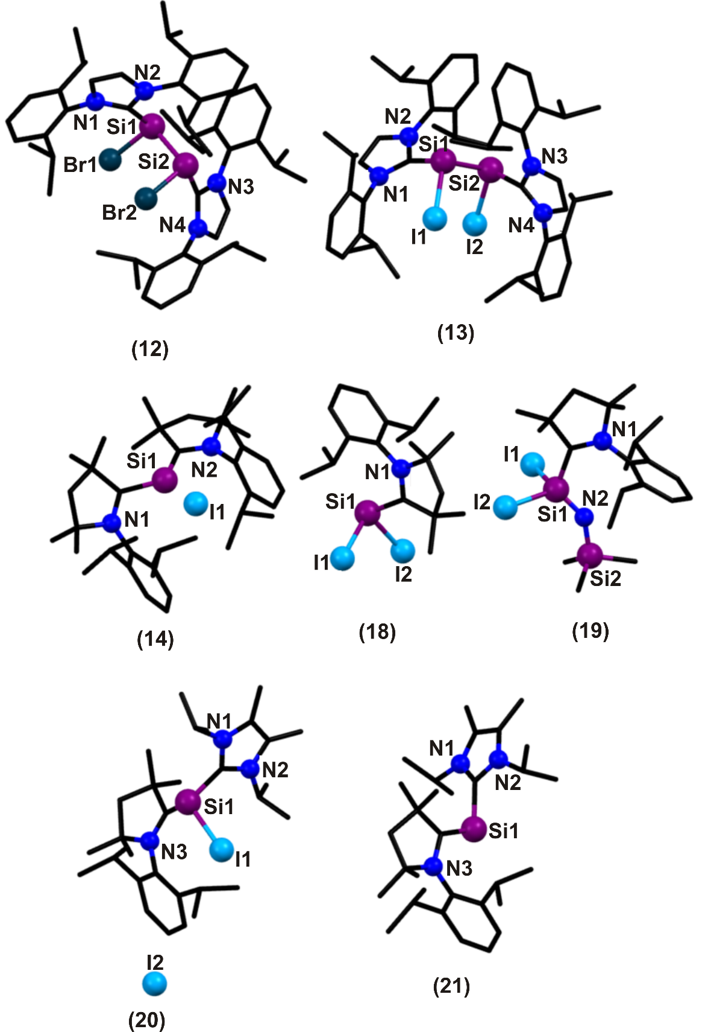

Fig. 3.
The presence of a lone pair of electrons on the silicon atom in 18 is evidenced by its reaction with 1.2 equivalents of trimethylsilylazide N₃SiMe₃ to form the cAAC-iminosilane complex [(cAACMe)Si(NSiMe₃)I₂] (19, Scheme 14), along with the evolution of N₂ gas. Compound 19 was isolated as an orange crystalline solid in high yield (87%). The ¹H NMR data of 19 shows resonances attributable to the cAAC_{Me} backbone and SiMe₃ substituent. The ¹³C NMR spectrum of compound 19 exhibits signal at δ=202.6 and upfield ²⁹Si NMR signals (δ = −180.7) for the CcAACSiN moiety imply that compound 19 has an ylidic cAAC_{Me}⁺-Si-N–skeleton. Conclusive evidence for the formation of 19 was acquired by single crystal X-ray crystallography (Figure 3). It reveals that, the Si1 atom in 19 adopts a tetrahedral geometry. The C1−Si1 bond (1.950(5) Å) is shorter than that of 18 (2.013(5) Å), as the oxidation state of the Si1 atom increases from +II to +IV. The DFT calculations show that the HOMO and HOMO−1are localized mainly on the N atom, indicating two lone pairs. The group charge analysis designates a charge flow from the SiI₂ (0.92 e) to NSiMe₃ (−1.21 e) fragments. 18 further reacts with one equivalent of the 1,3-diisopropyl-4,5-dimethylimidazol-2-ylidene IiPr (IiPr = :C-{N(iPr)CMe}₂) in n-hexane afforded the NHC-cAAC silyliumylideneiodide [cAAC_{Me}(SiI)IiPr]I (20; Scheme 14) as a yellow crystalline solid in 88% yield.¹H NMR spectrum shows one set of resonances due to the cAAC_{Me} and IiPr ligands. The ¹³CNMR signal for the C_{carbene} atom of cAAC_{Me} resonating at δ = 192.6, and this value almost identical to that of [cAAC_{Me}-H]OTf (δ = 192.2). The ²⁹Si NMR signal for 20 appeared at δ = −51.5. The solid state structure of 20 was determined by X-ray crystallography. The Si1 atom in the [cAAC_{Me}Si-(I)IiPr]⁺ of 20 adopts a trigonal pyramidal geometry, indicating the presence of a lone pair of electrons (Figure 4). The sum of bond angles at the Si atom of 20 (327.94°) is higher than that of 18 (299.66°). The C2−Si1 bond length (1.878(5) Å) is comparable with that of a typical C−Si single bond (1.87−1.91 Å).
Compound 21 was synthesized by the treatment of 20 with two equivalents of KC₈ in toluene at room temperature furnishes a bright red crystalline solid of 21 in 70% yield. The ¹H NMR spectrum of 21 shows one set of resonances due to the ligand backbones. The ²⁹Si NMR resonance for 21 shows a downfield shift at δ = 2.04 and compared with those of 20 (δ = −51.5). The solid state structure of 21 was determined by X-ray crystallography (Figure 3). The molecular structure of 21 exhibits a bent allenic C−Si−C skeleton where the two-coordinate Si center is supported by both NHC and cAAC. The CcAAC atom adopts a planar geometry. The “cAAC_{Me}Si” moiety is almost orthogonal to the N-heterocyclic ring of IiPr.
Scheme 14. Synthesis of 19, 20 and 21 [62].
3. Reactivity of NHC supported halosilylenes
Silylenes and halosilylenes serve a widespread role in many difficult reactions and rare synthesis. The NHC-SiCl₂ complexes are expected to be the structural motifs which are related to free SiCl₂. Since they are good source of divalent silicon, stable compounds having Si–C, Si–M (M = main group, transition metal), Si=Si multiple bonds can be formed easily. Rare compounds like small rings systems with high ring-strain energy containing silicon (silaoxirane), C4-silyl substituted NHC, dichlorosilamines (Si=N), silaisontriles, trisilaallenes (silicon analogue of allene) etc. are very suitably made using NHC stabilized silylenes. The halogen can be replaced by hydrogen (silahydride). Compounds which exists in the gas phase only (e.g. [ClSi:]⁺ , silacarbonyl halide) were also synthesized. The reason behind such reactivity is the presence of active lone pair on silicon centre and the stability imposed by NHC. Halosilylenes are ambiphilic in nature and are capable of accepting the carbene electron pair (electrophile) and can donate the lone pair of electron on Si. This property of halosilylenes can be exploited while making adducts with main group element which have vacant orbital to accept the electron pair. The acceptor bond (C→Si) is much polar (hard ligand) than the donor bond (Si→B) which is covalent (soft ligand). Thus the main group adduct of halosilylenes can be used to make Si–E (metal, O) bond by replacing boron. Similar types of reaction can also be used in making Si–M (transition metal) bonds.
3.1 Reactions of NHC:SiX₂ (X = Cl, Br, I, R) with S block and P block substrates
In general, the NHC-SiCl₂ complexes are expected to be the structural motifs which are related to free SiCl₂. This lability of NHC-SiCl₂ to liberate NHC and SiCl₂ was first demonstrated by Roesky et al., in 2009 by the reaction of 2 with excess of diphenylacetylene in toluene for the generation of 22 (Scheme 15 and Figure 4) [33]. 22 has a five membered SiC₄ ring. The silicon center is penta-coordinated with the two chlorine atoms occupying the axial position of a distorted trigonal bipyramidal polyhedron. Equatorial positions are occupied by two adjacent silicon and carbene carbon of L¹(NHC). Si–C_{carbene} bond distance is 1.911(17) Å. The other two silicon of the ring are in distorted tetrahedral environment. Si–Si bond distance is 2.323 Å (similar to α-Silicon, 2.36 Å). Si–Cl bond distance for SiCl₂ coordinated to L¹(NHC) is 2.254(7) Å which is slightly longer than L¹(NHC) free SiCl₂ i.e. 2.047(7) Å. The ²⁹Si NMR peaks are resonating at δ = -2.84 and -142.47.
Scheme 15. Reaction of L¹SiCl₂ (22) [33].
Si–C bonds can be formed by reacting silylenes with organic substrates. Small rings systems with high ring-strain energy containing silicon (silacyclopropane and silacyclopropene) are very reactive and are used to make organosilicon compounds. Silaoxiranes are three membered ring with one silicon, oxygen and carbon each. Isolation of siloxiranes was very difficult and was achieved by Roesky et al., only in 2010, by the reaction of 2 (dichlorosilylene) with ketone in toluene (23 and 24) and the reaction of ketone with PhC–(NtBu)₂SiCl (L³-monochlorosilylene) (25) (Scheme 16) (Figures 4) []. These silaoxiranes are electronically stabilized by neutral σ-donor (NHC). They also prepared 2,5-dioxa-1-silacyclopent-1-enes by reaction of a stable silylene (thermally or photochemically synthesized) with diketones (26) (Scheme 17) [63]. 23, 24, 25 and 26 were obtained as colorless crystals with penta-coordinated silicon centre. They are stable in inert atmosphere and soluble in common organic solvents. The ¹H NMR spectrum of 23, 24 and 26 show one set of resonance for NHC ligand in common and 25 shows two resonances for the amidinate moiety. All the ligands show signals for phenyl group attached to OSiC or O₂SiC₂ ring in the appropriate regions. ²⁹Si NMR displays sharp signals at δ=-123.85, -123.39, -115.53 and -99.50 for 23, 24, 25 and 26 respectively. 23 has one toluene molecule in the asymmetric unit and 24 has half molecule of n-hexane in the asymmetric unit with distorted trigonal bipyramidal geometry. Both the NHC ligands occupy the axial position. The C→Si bond length is 1.9653(15) Å in 23 and 1.9724(17) Å in 24. Si–Cl bond is relatively shorter in both 23 and 24 when compared to 2. Si–O bond in 23 (1.6520(10) Å) and 24 (1.6486(13) Å) are slightly shorter than that reported for silaoxirane which may be due to presence of two electronegative chlorine atom. 25 has distorted square pyramidal geometry. The Si–O and Si–C bond distances are 1.653(13) Å and 1.864(19) Å, respectively. Si–Cl bond length is 2.011(6) Å which is shorter than that in PhC(NtBu)₂SiCl (2.016(1) Å) and is in good agreement with those of 23 and 24. 26 crystallizes in trigonal-bipyramidal geometry. One chlorine atom occupies axial position and another chlorine resides in the equatorial position and as expected their bond lengths differ significantly (axial 2.203(8), equatorial 2.081(8) Å). The oxygen atoms of the planar five-membered ring chelate axial and equatorial positions. The NHC ligand occupies the equatorial position, and the Si–C distance (1.939(2) Å) is comparable to those in 23 and 24.

Scheme 16. Reaction of L¹SiCl₂ (23 & 24) and L³ (25) with ketone [63].
Scheme 17. Reaction of L¹SiCl₂ (2) with diketone (26) [63]
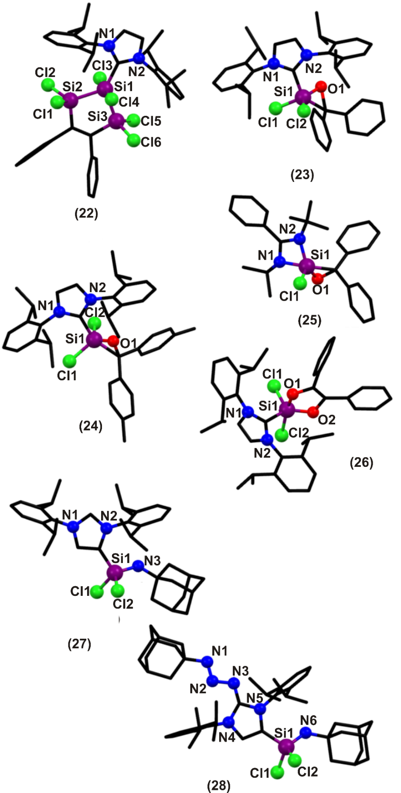
Fig. 4.
In the same year, Roesky et al., synthesized abnormal C4-silyl-substituted NHC (27) by oxidative addition and C–H activation of 2 with 1-azidoadamantane (AdN₃) at -78 °C in toluene (Scheme 18) []. It showed similar reactivity as that of NHC-stabilized dichlorosilylenes which was isolated as colorless crystals with 87% yield. NHC 27 was characterized by elemental analysis and ¹H, ¹³C, and ²⁹Si NMR spectroscopic studies. The backbone proton of NHC (27) appears as a singlet (δ = 7.45) that is shifted downfield by Δδ = 0.83 the appearance of a new resonance in the ¹³C NMR spectrum of NHC 27 at δ = 224.21 (C2, carbene carbon) clearly revealed the formation of new NHC 27 adduct. Single-crystal X-ray structure analysis confirmed the insertion of the aminosilyl group into the C-H bond at the C4 position of Idipp to afford new NHC 27, which has a toluene molecule in the asymmetric unit (Figure 4).
Scheme 18. Reaction of L¹SiCl₂ (2) with N₃Ad (27) [64].
Similar to this, 27 can react with 1 equivalent of N₃Ad to give 28. 28 can also be obtained by reacting 2 equivalents of N₃Ad with 2 (Scheme 19) [64]. ¹H NMR spectrum of 28 emerges at δ = 5.88 for backbone proton (NCH) and other ¹H NMR resonances were observed as expected. Compound 28 shows ²⁹Si NMR resonance at δ = -34.34, which is in agreement with those reported for aminosilanes. Comparison of the crystallographic data for 28 with those for reported donor-acceptor triazines revealed that 28 consists of a shorter N–N single bond [N4–N5, 1.380(3) Å] and a longer N–N double bond [N5–N6, 1.257(3) Å] (Figure 4). The C1–N4 bond in 28 is slightly shorter than those in unsubstituted NHC-derived triazenes, indicating better acceptor properties of C1.
Scheme 19. Reaction of L¹SiCl₂ (2) and 27 with N₃Ad (28) [64].
Silamines are compounds with polarized Si=N bond having alkyl or aryl group on N-wingtip which gives additional stability. In 2010, Roesky et al., synthesized NHC stabilized dichlorosilamines using aryl azides in the presence of toluene. The reaction of Idipp.SiCl₂ (2) with bis(2,6-diisopropylphenyl)-carbodiimide afforded NHC-stabilized dichlorosilaimine Idipp.Cl₂Si=N(diip) (29). 2 reacts with an equimolar amount of diip or 2,6-Triip₂-C₆H₃N₃ with clean formation of dichlorosilaimines Idipp.Cl₂Si=N(diip) (30) and Idipp.Cl₂Si=N(2,6-Triip₂-C₆H₃) (31), respectively (Scheme 20) []. All the compounds (29, 30 & 31) were isolated as yellow crystalline solids and were stable under inert atmosphere. Dichlorosilaimines (29, 30 & 31) were characterized by elemental analysis, and ¹H, ¹³C, and ²⁹Si NMR spectroscopic studies. ²⁹Si NMR resonances for 29, 30 & 31 appear at δ = -107.07, -99.95, and -99.70, respectively, which are shifted up-field with respect to 2 (δ = 18) due to higher coordination of silicon atoms and are consistent with Si(IV) compounds. The molecular structures of compounds 29, 30 and 31 were established by single-crystal X-ray crystallography (Figure 5). Compound 29 exhibits a distorted tetrahedral geometry. Two coordination sites of the silicon atom are occupied by two chlorine atoms, the third one is occupied by the C atom of the NHC, and the fourth site is occupied by one N atom of the imine moiety. The silicon atom in 30 and 31 is four-coordinate, and the sum of the bond angles around silicon shows that the compound will exhibit a distorted tetrahedral geometry. The NHC ligand, the Cl atoms, and imine N atom in 27 and 28 are arranged in a similar fashion to those in 29. The average bond length for 29, 30 and 31 is 1.565(4) Å. The Si–C_{carbene} bond distance is 1.917(5), 1.953(2) and 1.938(2) Å in 29, 30 and 31, respectively.

Scheme 20. Reaction of L¹SiCl₂ (2) with arylazide (29, 30, 31) [65].
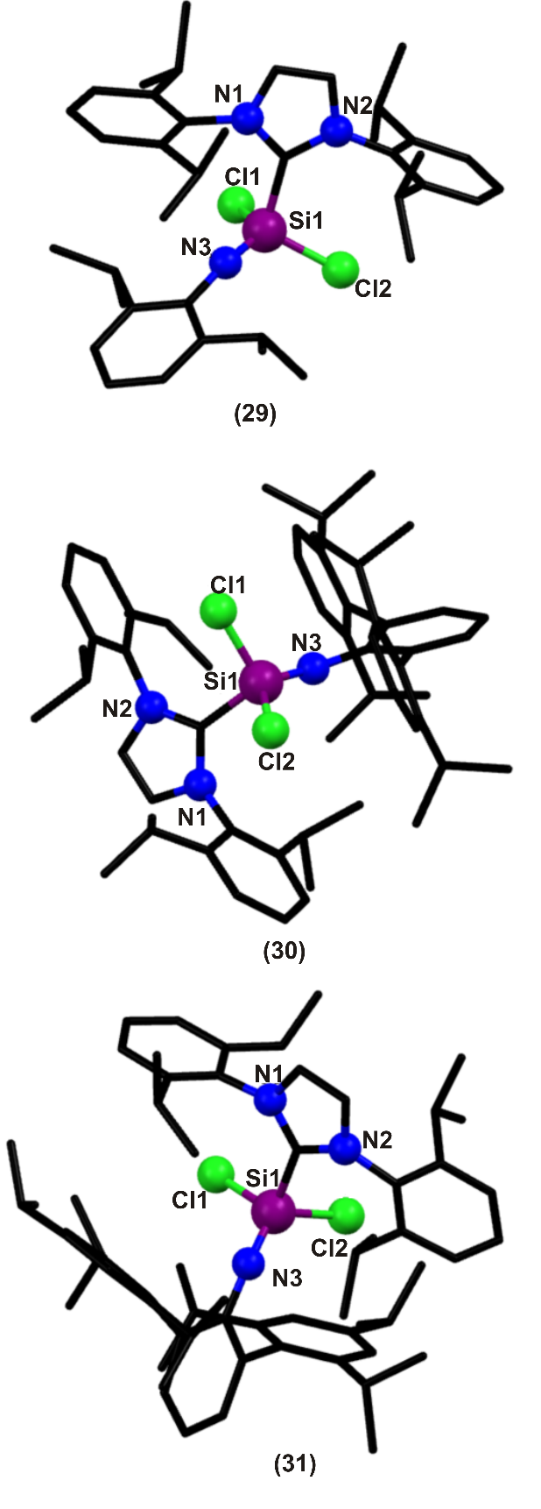
Fig. 5
Organic nitriles and isonitriles are very stable, but their silicon analogues are only detected as transient species in low-temperature argon matrix. Based on this, silaisonitrile (ArNSi:)₂ (32) was prepared by the reduction of dichlorosilamine (28) with KC₈ in presence of toluene (Scheme 21) []. Dimerization of 31 by [2+2] cycloaddition under elimination of two molecules of Idipp affords 32 as yellow crystalline blocks in 21% yield. Furthermore, the treatment of 32 with trimethylsilyl azide (Me₃SiN₃) gives the first bis(silaimine) 33 (Scheme 22) [66] with three-coordinate silicon atoms as a colorless crystalline solid in 62 % yield. Formation of 33 confirms the presence of a reactive lone pair of electrons on each of the silicon atoms of 32. Compounds 32 and 33 are stable under an inert atmosphere and are soluble in common organic solvents. ¹H and ¹³C NMR spectra of 32 show resonances for terphenyl ((2,4,6-iPr₃-C₆H₂)₂C₆H₃) groups on amino nitrogen atoms. ²⁹Si NMR chemical shift at δ = 183.29 for 32 indicates strong deshielding, as expected for compounds with low-valent silicon atoms. The ²⁹Si NMR spectrum of 33 exhibits two resonances at δ = 2.76 and -56.82 for trimethylsilyl (SiMe₃) and silaimine (ArNSi=N) moieties, respectively. The molecular structures of 32 and 33 were established by single-crystal X-ray diffraction studies (Figure 6). Each silicon atom in 32 is two coordinate, and the four membered Si₂N₂ is almost planar. The endocyclic N–Si–N (86.02(6)8º) and Si–N–Si (94.02(9)8º) angles of the Si₂N₂ ring are nearly orthogonal to each other. The phenyl rings on the amino nitrogen are almost perpendicular to one another, with a dihedral angle of 83.078°. 33 has half of the molecule and a molecule of toluene in the asymmetric unit. Each of the silicon atom in the four-membered Si₂N₂ ring of 33 is three-coordinate. The endocyclic Si–N bond lengths in 33 (av.1.724(2) Å) are slightly shorter in comparison to those observed for 32 (av. 1.755(1) Å). Compound 33 is the first example of a base-free bis(silaimine) with two three-coordinate silicon atoms.
Scheme 21. Reduction of 31 to make silaisonitrile (32) [66].

Scheme 22. Reduction of 32 to make bis(silaimine) (33) [66].
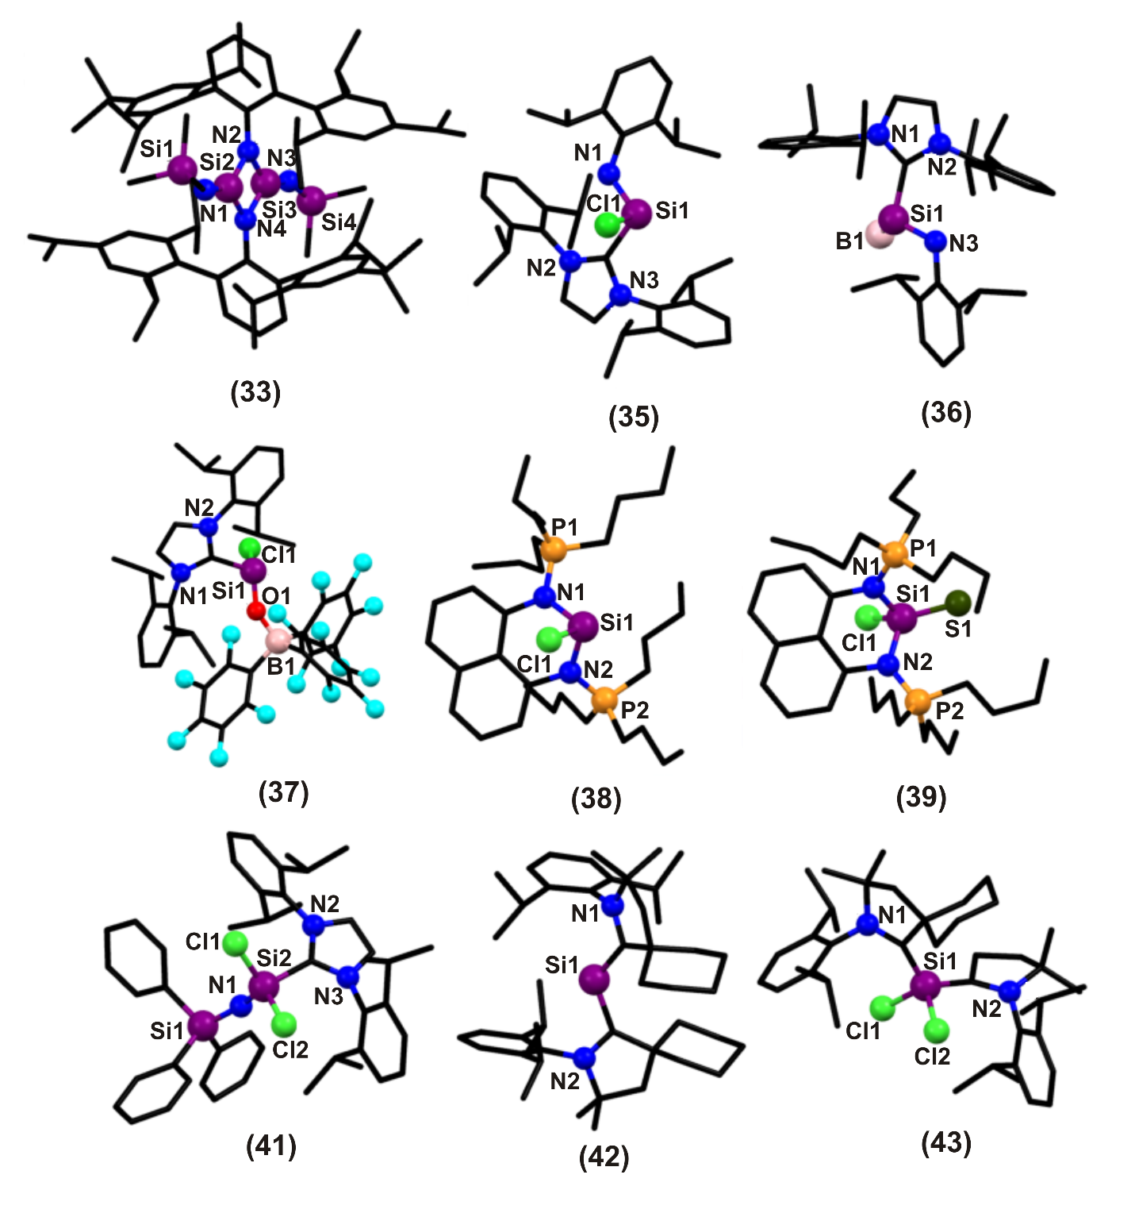
Fig. 6.
The silicon analogues of allenes remain meager due to their deprived stability. Trisilaallene has a flexible Si=Si=Si skeleton. The origin of the bent and fluxional skeleton of heavier allenes were elucidated by Jahn-Teller distortion allied with the effectual incorporation of the π and σ* orbitals. The first isolable tetrasilyl-substituted trisilaallene, viz, 1,1,3,3- tetrakis(di-tert-butylmethylsilyl)trisilaallene (34), was synthesized by Sekiguchi et al., in 2011 []. The reaction of dilithiosilane (tBu₂MeSi)₂SiLi₂ with dichlorosilylene-NHC complex 2 in benzene at room temperature afforded air and moisture sensitive red solid, trisilaallene (34) in 40% yield (Scheme 23). The structure of trisilaallene 34 was determined by HRMS and ¹H, ¹³C, and ²⁹Si NMR spectroscopic studies. In the ¹H NMR spectrum of 34 shows two signals for tBu and CH₃ groups of tBu₂MeSi substituents in the appropriate region. ²⁹Si NMR spectrum of 34 shows three signals at δ=22.4, 44.6, and 418.5 that are assignable to the substituent silicon atoms (tBu₂MeSi), terminal silicon atoms (Si=Si=Si), and central silicon atom (Si=Si=Si), respectively. The UV-vis absorption spectrum of 34 in hexane shows an absorption band at 400 nm (ε 3400 M⁻¹cm⁻¹) assignable to π-π* transition. Theoretical calculations show that the central bent angle is 164.3° which is larger than the un-substituted trisilaallene. This is due to the electronic effect of the silyl substituents and the steric effect of the four bulky tBu₂MeSi groups. The Si=Si bond distances are 2.1792 and 2.1742 Å. The terminal silicon atoms of Si=Si=Si are slightly pyramidalized i.e., they are not planar. Also, it undergoes thermal isomerization to thermodynamically more stable cyclotrisilene (orange-red crystals) at high temperatures.
Scheme 23. Reaction of 2 with dilithosilane to make trisilaallene (34) [67].
NHC stabilized aminohydride complexes of general formula Idipp·E(H)NH-diip (E=Si, Ge, and Sn) have been synthesized from the known adducts, Idipp·ECl₂ (E=Si, Ge, and Sn) with one equivalent of Li-[NHdiip] in Et₂O (Scheme 24) [a]. 35 was isolated as yellow air and moisture sensitive solid in 45 % yield. The formation of adduct 35 was confirmed by elemental analysis, NMR and IR spectroscopy. The ¹H NMR data of 35 show well-resolved singlet resonance corresponding to the N–H group at δ = 4.14. Moreover, the six -CH₃ groups exists in a magnetically distinct environment, reflecting the presence of a high degree of intramolecular crowding in the chloroamide complex. In ²⁹Si NMR the compound 35 exhibits signal at δ = -6.0, which is positioned up-field relative to that of the Si(II) precursor, Idipp·SiCl₂ (δ = 19.1) (2). Conclusive evidence for the formation of Idipp·Si(Cl)NHdiip was acquired by single-crystal X-ray crystallography (Figure 6). It revealed that the three-coordinate Si center in 35 exhibits a distorted trigonal pyramidal geometry. This is consistent with the presence of a stereochemically active lone pair at the tetrel element center. Furthermore, Si–Cl bond in 35 is oriented towards the steric cradle that is created by the flanking diip group of the Idipp donor (L¹). The Si–N bond length is 1.765(2) Å which is slightly longer than the Si–N bond of Roesky’s dimeric silaisonitrile (35).
Scheme 24. Reaction of L¹SiCl₂ (2) with Li[NHdiip] to make Si(II)amidohalide (35) [68a].
35 further reacts with one equivalent of Li[BH₄] in Et₂O gives mixture of L¹·SiH(BH₃)NHdiip (36), L¹·(BH₂)NHdiip, L¹BH₃ and L¹H₂ (Scheme 25(i)) [68a]. The silicon(II) hydride complex was isolated in pure form with 38% yield. The product formation was initially confirmed by ¹H NMR spectroscopy in which 36 shows broad SiH resonance with resolvable flanking ²⁹Si satellites (¹J_{SiH}=160.3 Hz), located at δ = 5.13. The proximal amide proton in the -NHdiip group was detected as doublet resonance peak at δ = 1.94 (³J_{HH}=5.5 Hz), with the observed pattern resulting from the coupling of an NH hydrogen atom with the adjacent silicon-bound hydride. Coordinated BH₃ in 36 was confirmed by ¹¹B NMR showing a quartet resonance at δ = -44.1 with an expected coupling constant of ¹J_{BH}=89.5 Hz. IR spectrum shows an absorption band at 3559 cm⁻¹ corresponding to N–H stretching vibration, a broadened ^{10/11}B–H stretching mode appeared in the region 2326 to 2237 cm⁻¹, and a sharp Si–H stretching band at 2096 cm⁻¹. Additional evidence for the formation of the silylene borane adduct was confirmed by X-ray crystallography (Figure 6). The 36 represents formal donor–acceptor complex of encapsulated, heavy group 14 amidohydride unit with the four-coordinated Si center located within slightly canted transoid IdippC–Si–N–Cdiip bonding arrangements (torsion angle = 177.58(13)º). The dative C_{Idipp}–Si bond length in 36 is 1.943(15) Å and the adjacent Si–B bond length in 36 is 1.976(19) Å.
Scheme 25. (i) Reaction of 35 with Li[BH₄] to make Si(II)amidohydride (36) [68a]; (ii) Reaction of L¹SiI₂ (9) with diazoalkanes (36a) and azides (36b) [68b].
The reactivity of Si(II) compounds with 1,3-dipoles have been extensively studied. Depending on the reactants and the reaction conditions various products were obtained. However, the reaction of silicon(II) compounds with diazoalkanes is only scarcely explored. A detailed study of the reactivity of the NHC-stabilized silicon(II) halides SiI₂(Idipp) (9) towards diazoalkanes and azides was carried out by Filippou et al. [68b]. Treatment of 9 with the diazoalkanes (p-Tol)₂CN₂ (p-Tol = C₆H₄-4-Me) afforded the NHC-stabilized silazines SiI₂{N₂C(p-Tol)₂}(Idipp) (36a) as orange to yellow solid (Scheme 25(ii)). No N₂ elimination from the diazoalkanes was observed in these reactions. However, the reactions of 9 with the covalent azide MesN₃ yielded after N₂ elimination the yellow to colorless NHC-stabilized silaimines SiI₂(NMes)(Idipp) (36b) (Scheme 25(ii)). All the compounds were characterized by FTIR, NMR, X-ray diffraction and elemental analyses.
Formyl chloride is a very reactive and useful reagent used in several organic reactions for formylation. Formyl chloride (H(Cl)C=O) is unstable at room temperature and decomposes to HCl and CO. It’s silicon analogue was more challenging to synthesize. The first stable silaformyl chloride Idipp.SiH(Cl)=O.B(C₆F₅)₃ (37), which was synthesized from the reaction of 2 with H₂O.B(C₆F₅)₃ in the presence of NHC as a HCl scavenger (Scheme 26) []. 37 was isolated as colorless crystals from toluene solution in 26% yield. It is soluble in common organic solvents and is stable under inert atmosphere for a fairly good time. There is a significant double bond character between Si and O atom in 37 and it also has a resonating form. ¹H NMR spectrum shows a broad resonance for Si–H proton at δ = 5.55 and ²⁹Si{¹H} NMR spectrum shows a peak resonating at δ = -49.78. The ²⁹Si NMR resonance for 37 shows a significant up-field shift relative to dichlorosilylene 2, which is comparable to those of reported silicon compounds with an Si=O bond. The solid-state structure of 37 was determined by X-ray crystallography which indicates that the silicon center is in distorted tetrahedral environment (Figure 6). All coordination sites are occupied by four different atoms; a hydrogen, a chlorine, an oxygen, and a carbon atom of the NHC ligand. The Si–O bond distance is 1.568(15) Å which is smaller than Si–O single bond length (1.64 Å) and larger than the Si–O double bond length (1.53 Å). The Si–Cl and Si–C_{carbene} bond distances are 2.049(8) Å and 1.911(2) Å, respectively, which are shorter than that in 2.
Scheme 26. Reaction of 2 to make silaformyl chloride (37) [69].
Divalent silicon cations (silyliumylidene cation; [RSi:]⁺; R = H, halogens, organo groups) are very hard to synthesize, so they are still scarce. Silyliumylidenes are most attractive versatile building blocks and Lewis acid catalysts. Hence, monochlorosilyliumylidene [ClSi:]⁺ appears to be a very promising silyliumylidene precursor, because the chlorine atom could be replaced by suitable nucleophiles to pave the way to other types of silyliumylidene derivatives [RSi:]⁺. They are very unstable and are found in gas phase. In this context, Driess et al., synthesized the first isolable chlorosilyliumylidene species 38 stabilized by the bis(iminophosphorane) chelate ligand. Compound 38 was synthesized by reacting bis(iminophosphorane) and equimolar amount of 2 in toluene at room temperature furnished 38 with an isolated product yield of 46% (Scheme 27) []. It is air and moisture sensitive but stable in solid state under inert atmosphere. Complex 38 was structurally characterized by single crystal X-ray diffraction. Its structure shows that the silicon center is threefold-coordinated with one Cl and two nitrogens from the bis(iminophosphorane) chelating agent in tetrahedral environment (Figure 6). The other anionic chlorine is situated far away at the smallest distance of 6.704 Å. It must be noted that the degree of pyramidalization at the silicon atom in 38 (286.68°) is close to that in 2 and 4 (289.78°). In 38, the six-membered C₃N₂Si ring is puckered and the silicon atom is out of the plane that is defined by the C₃N₂ atoms. The dihedral angle between the planes defined by C₃N₂ and N₂Si is 38°. The Si–Cl bond distance is 2.172(2) Å which is almost close to the mean Si–Cl (2.166(2) Å) distance in 2. The two Si-N bond distances are almost identical (1.874(3) Å and 1.835(3) Å). The average P–N distance is 1.663 Å which lies between the P–N single and double bond lengths. The ³¹P NMR spectrum shows that it is downfield shifted to δ = 57.7 than the precursor which is at δ = 11 in [D₂] dichloromethane. A triplet at δ = -3.3 (²J(Si,P)= 22.3 Hz) was noted in ²⁹Si{¹H} NMR spectrum.
Scheme 27. Reaction of 2 to make chlorosilyliumylidene chroride and chlorosilathonium complex (38 & 39) [70].
Further, 38 reacts with elemental sulfur in THF at ambient temperature to form the chlorosilathionium complex (39) in 81% yield (Scheme 27) [70]. The ³¹P NMR spectrum of 39 shows a singlet at δ = 66. X-ray analysis revealed that the silicon centers are four-coordinated flanked by two nitrogen atoms from the chelate ligand, one chlorine atom, and one sulfur atom resulting in a tetrahedral geometry (Figure 6). The six-membered C₃N₂Si ring is more puckered with a dihedral angle of 49.6° and 49.3° between C₃N₂ and N₂Si planes compared to that in 38 (38°). The increase in coordination number of 39 (+IV) from 38 (+II) results in shortened Si–Cl (2.087(2) Å) and Si–N (1.785 Å) bond lengths. The Si=S bond distances are 1.984(2) Å and 1.977(2) Å, which is very close to that reported for related donor-supported Si=S complexes. 39 acts as a potentially strong Lewis acid catalyst in organic transformations.
Vinylsilanes are important alkene derivatives that have been widely used as synthetic intermediates, monomers for copolymer plastics, and coupling agents for hybrid silicon containing materials. These vital compounds are generally synthesized by the reaction of transition metal catalysed hydrosilylation and bis-silylation of alkynes. According to that, the bis-silylation reaction of alkynes without using any transition metal catalyst with the help of NHC-stabilized silylaminosilylene (7) was reported by Cui et al., in 2012 []. The NHC-supported silylaminosilylene Ar-(SiMe₃)N(Cl)Si(IiPr) (40) (Ar = 2,6-iPr₂C₆H₃, IiPr = 1,3-diisopropyl-4,5-dimethylimidazol-2-ylidene) is an efficient and stereospecific bis-silylation reagent for a range of functionalized alkynes to yield cis-1,2-bis-silylated alkenes via a 1,4-silyl migration from the amino nitrogen atom to an alkyne carbon atom (Scheme 28). The reaction is highly stereospecific and proceeds via 1,4-silyl migration from the silylamino nitrogen atom to one of the alkyne central carbon atom.
Scheme 28. Reaction of stereo- and regio-selective bis-silylation of terminal alkynes under metal-free conditions (40) [71].
The direct methods for silaimine synthesis are limited and silaimines with less bulky terminal groups are still meager. The reaction of Lewis base-stabilized dichlorosilylene 2 with Ph₃SiN₃ afforded four-coordinate silaimine L²(Cl₂)SiNSiPh₃ (41) in quantitative yield (Scheme 29) []. Compound 41 is soluble in toluene, benzene, and THF and is stable under inert atmosphere and was characterized by elemental analysis, NMR spectroscopy, and single-crystal X-ray studies (Figure 6). The ²⁹Si NMR spectrum shows two peaks at δ = -29.64 for SiPh₃ and δ = -75.25 for SiCl₂. The structural analysis of 41 illustrates that the silicon center shows distorted tetrahedral geometry. The average Si–Cl bond distance is 2.075(11) Å and the Si–C_{carbene} bond distance is 1.924(3) Å which are both shorter than 2. The Si–N bond length is 1.581(2) Å.
Scheme 29. Reaction of 2 to make silaimine (41) [72].
Radicals and biradicals are extremely reactive chemical species, which can act as key intermediates in many chemical and biological processes. But their isolation and characterization is much more complicated. In 2013, Roesky et al., developed a notable synthetic pathway for air-stable 1,3-biradicals (L·)₂SiX₂ (X= Cl, Br) using L¹.SiCl₂ and cAAC (cyclic alkyl(amino) carbene). 42, 43, 44 and 45 were synthesized by reacting L¹-SiX₂ with three equivalents of the required cAAC in THF at room temperature (Scheme 30(i)) (Figures 6 and 7) [a]. The percentage yield of 42 and 43 depend on the ratio of L¹-SiX₂ and cAAC. 43 is obtained as blue plate crystals and stable upto a week in air like 42. 44 was isolated as microcrystalline solid, which is stable in an inert atmosphere showing its instability. 45 was isolated as large blue blocks in 46% yield. The ²⁹Si NMR measurements of compounds 42, 43, 44 and 45 are silent. The absorption spectrum shows a maxima ranging from 565 to 585 nm for all. 42 exhibits a distorted tetrahedral geometry. The Si–C_{carbene} bond distance is 1.845(16)/1.848(17) Å. 43 and 45 are isostructural with half n-hexane in the asymmetric unit. The Si–C_{carbene} bond distances in 43.0.5 n-hexane is 1.854(2)/1.859(18) Å and in 45.0.5 n-hexane is 1.843(2)/1.850(18) Å.
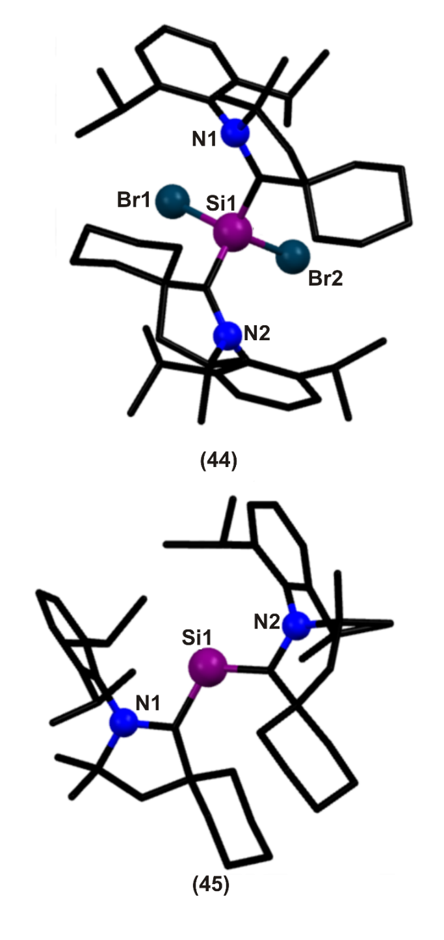
Fig. 7.
An unprecedented NHC-stabilized bromo(silyl)silylene was synthesized by Filippou et al., starting from SIdippSiBr₂ [73b]. Heating of a 2:1 mixture of SiBr₂(SIdipp) and (E)-Tbb(Br)Si=Si(Br)Tbb in toluene at 100 °C for 5 h was accompanied by a color change from yellow to orange. The reaction is two-step process, the base-stabilized silylene intermediate is formed first, which rapidly rearranges to NHC stabilized bromo(silyl) silylene (45a) via a 1,2-migration of a bromine from the four-coordinated Si to the three-coordinated Si center (Scheme 30(ii)) (Figure 7a). Compound 45a can also be prepared from the 2:1 reaction of SiBr₂(SIdipp) with LiTbb at low temperature. Compound 45a was characterized by elemental analysis, single-crystal X-ray diffraction analysis and ¹³C, ²⁹Si NMR spectroscopy. The geometry at the silicon centers are different: the Si2 center has trigonal-pyramidal geometry whereas the geometry at Si1 is tetrahedral geometry (Figure 7a). Both the bulky substituents, SIdipp and Tbb and the bromine atoms adopt almost antiperiplanar conformation. The ²⁹Si NMR spectrum of 45a displays two singlets at δ = -11.3 and -1.9, which were assigned by ¹H–²⁹Si correlation spectroscopy to the SiBr₂ and SiBr nuclei, respectively. Compound 45a contains several reactive sites upon reduction with two equivalents of KC₈ in benzene afforded the NHC-stabilized disilavinylidene 45b (Scheme 30(iii)) (Figure 7a).
Scheme 30: (i) Synthesis of biradical (42-45) [73a]. (ii) Synthesis of NHC-stabilized bromo(silyl)silylene (45a) [73b]; (iii) Synthesis of NHC-stabilized disilavinylidene (45b) [73b].

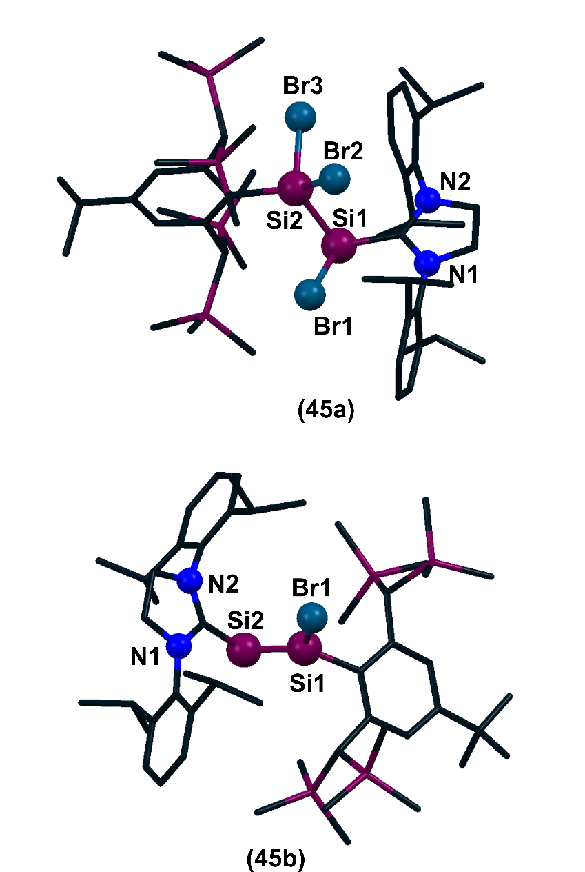
Fig. 7a.
NHC-stabilized iodosilylenes are very reactive, as the presenting iodide group which serves as a good leaving group and undergoes displacement reaction to give cationic silicon (II) species. The compound Si(IMe₄)₃]²⁺I⁻ (46) was synthesized by the reaction of 1,3,4,5- tetramethyl-imidazole-2-ylidene (IMe₄) to L¹SiI₂ (9) in presence of fluorobenzene as light yellow powder with a yield of 79% (Scheme 31) [55]. The complex salt 46 is soluble in CH₂Cl₂, however it slowly decomposes after several hours at ambient temperature. The dication [Si(IMe₄)₃]²⁺ has C₃ symmetry with propeller like pyramidal structure. The nearest Si–I distance is 5.85 Å. The positive charge on silicon center is delocalized between the three imidazole rings making the Si–C_{carbene} bond distance to be 1.915(3) Å. The ²⁹Si{¹H} NMR spectrum in CD₂Cl₂ displays a strongly shielded ²⁹Si NMR peak at δ = -89.9. The ¹³C{¹H} NMR spectrum shows unique C_{carbene} signal at δ = 150.7. The crystal structure of 46 shows well separated 46 ions and iodide counter anions, the closest Si···I contact (5.88 Å) being much longer than the sum of the van der Waals radii of silicon and iodine (4.08 Å) (Figure 8) []. The dication 46 has an almost C₃ symmetric, propeller-like, pyramidal structure.
Scheme 31. Reaction of L¹SiI₂ to make cationic silicon(II) compound (46) [55].
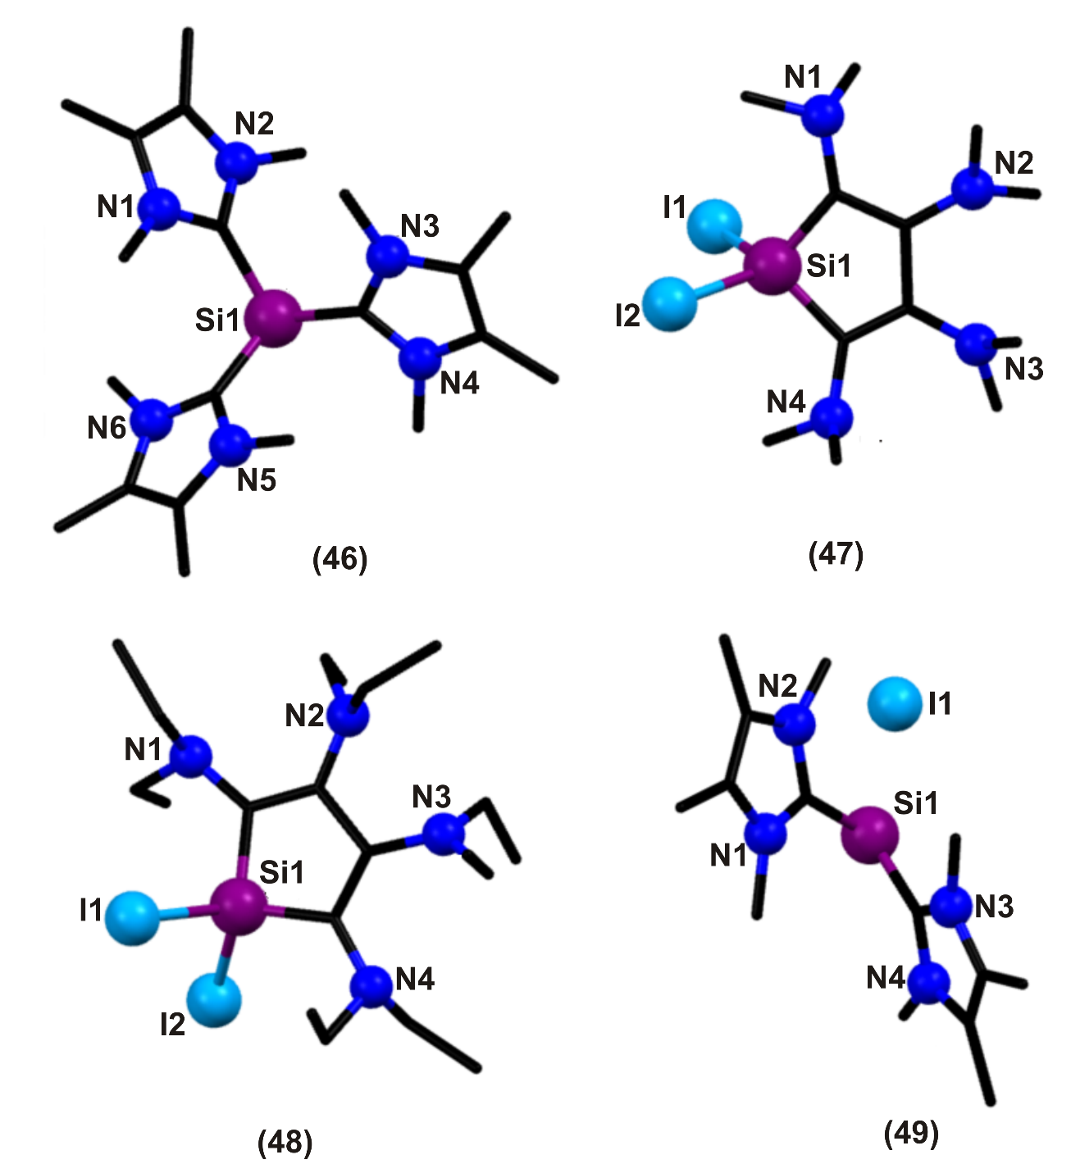
Fig. 8.
Using this same property of L¹SiI₂, in 2014, Filippou et al., reported the synthesis of silicon containing five membered ring. The reaction of L¹SiI₂ (9) with two equivalents of bis(dialkylamino)acetylene (R₂N–C≡C–NR₂) in benzene yielded tetra(dialkylamino)-1-H-silole, SiI₂(C₄(NR₂)₄), where R can be methyl (47) or ethyl (48) (Scheme 32) []. Both the compounds were isolated as orange, water sensitive crystals in n-hexane at -60 °C (47) and -30 °C (47). 47 decomposes to a black mass at 111 °C and 48 melts at 85 °C without decomposition. The molecular structures of 47 and 48 were determined by single-crystal X-ray diffraction analyses (Figure 8). The Si–C bond distances are between 1.827(11)-1.854(2) Å. The Si–I bond distance is 2.463 Å in 47 and 2.466 Å in 48. All the amino groups are rotated out of the 5-membered ring (amino groups attached to C1 and C4 are rotated more than that attached to C2 and C3) resulting in minimum steric repulsion between the adjacent amino groups. Furthermore, the amino groups are pyramidal. The C_{ring}–N bond lengths are between 1.39-1.43 Å (close to C_{sp}²–N_{sp}³). ¹H and ¹³C NMR spectrum displays single set of resonance for N-alkyl substituents and hence it confirms the rapid rotation of amino groups. The ²⁹Si NMR spectrum shows peak at δ = -87.8 for 47 and δ = -83.5 for 48 in C₆D₆. Compound 48 upon reaction with excess of SiBr₄ in benzene at ambient temperature yielded its bromo analogue (48a) as orange solid with a yield of 78%. Compound 48a is found to be highly water sensitive and low melting solid. The reaction of 48 with excess SiBr₄ in n-hexane did not proceed, which indicates the influence of solvent polarity. ²⁹Si NMR signal of 48a appears at δ = 13.4 in C₆D₆ which is considerably low field shifted than that of compound 48 (δ = -83.5 in C₆D₆)and that of SiBr₄ appears (δ = 90.8 in C₆D₆).
.
Scheme 32. Reaction of L¹SiI₂ (4) to make tetra(dialkylamino)-1-H-silole (47 & 48) and reaction of 48 with excess of SiBr₄ to form its bromo analogue 48a [75].
The cleavage of the Si–Si bond in a silicon(I) dimer with NHCs to generate an NHC–silicon(I) radical intermediate, which then rearranges to form an NHC–parent-silyliumylidene cation complex was explored by Li et. al. The reaction of the NHC–iodosilicon(I) dimer [IAr(I)Si:]₂ (IAr=:C{N(Ar)CH}₂) with four equiv of IMe (:C{N(Me)CMe}₂) in toluene afforded the first NHC–parent-silyliumylidene iodide [(IMe)₂SiH]⁺I⁻ as orange crystals (49; Scheme 33) [58]. They are fairly stable under an inert atmosphere for two months but highly unstable in solution. They instantly decompose in THF and CHCl₃ and slowly decompose in fluorobenzene and pyridine. 49 was confirmed by NMR spectroscopic analysis. In ¹H NMR spectrum two sets of resonances were observed, one corresponding to I_{Me} ligands and the other one corresponding to Si-H proton (in the region δ = 9.73). The ²⁹Si NMR signal of 49 resonating at δ = –77.9 (J_{Si,H} = 283 Hz). The X-ray crystal structure of 49 shows a separated ion pair with a Si···I distance (10.013 Å) that is longer than the sum of their van der Waals radii (ca. 4.08 Å) (Figure 8). The center Si atom in 49 has trigonal-pyramidal geometry. The sum of the bond angles at the Si atom (292.19°) indicates the presence of a stereo active lone pair at the silicon atom. The Si–C bond length values are 1.932(3) and 1.931(3) Å. The hydrogen atom bound to the Si1 atom was situated in the electron difference map and refined isotropically to the estimated Si–H bond length of 1.455 Å [].
Scheme 33. Reaction of the NHC–iodosilicon(I) dimer with IMe (:C{N(Me)CMe}₂) (49) [58].
Silylenes are considered as silicon analogues of carbenes, existing as a neutral bivalent silicon atom with two nonbonding electrons as the HOMO, which possesses nucleophilic character, and an empty p-orbital as the LUMO, which exhibits electrophilic character. Encompassing both the nucleophilic and electrophilic reactive sites at the silicon atom, silylenes are considered to have an ambiphilic character and behave as Lewis acids as well as Lewis bases. Due to the availability of both nucleophilic and electrophilic reaction center, the chemistry of silylenes is of intense interests to scientists. The above said properties implies that 2 is a σ-donor ligand having stereochemically active lone pair of electrons at the silicon atom.
Roesky et al., reported the use of NHC-stabilized dichlorosilylene L¹SiCl₂ (2) as a base in the reaction with B(C₆F₅)₃ in the presence of toluene to give the silylene–borane adduct L¹→SiCl₂→ B(C₆F₅)₃ (50) (Scheme 34) []. Adduct 37 is a novel example showing both acidic and basic properties of dichlorosilylene in a single molecule, as σ-acceptor as well as σ-donor. This reaction is unsuccessful with B(OPh)₃ and BF₃.Et₂O. The compound 50 is soluble in common organic solvents and is stable under inert gas atmosphere. 50 has been characterized by elemental analysis, ¹H, ¹¹B, ¹³C, ¹⁹F, ²⁹Si NMR spectroscopy, and ESI mass spectrometry. The molecular structure of 50 was studied using single-crystal X-ray diffraction and DFT calculations with subsequent topological analysis (Figure 9). The ¹H NMR spectrum of 50 exhibits resonances for the NHC ligand bound to the Si atom (δ = 0.80 (CHMe₂), 1.15 (CHMe₂), 2.62 (CHMe₂), 6.29 (NCH), 6.89 (m-C₆H₃), 7.02–7.07 (p-C₆H₃)) with an up-field shift relative to 2. The ¹¹B NMR spectrum of 50 shows a broad resonance consistent with a four-coordinate boron atom. The ¹⁹F NMR resonances exhibit in the expected region. In ²⁹Si NMR spectrum of 50 resonance shifted to higher field at δ = -53.19 than 2. Compound 50 crystallizes as a twin with toluene molecules in the crystal lattice (Figure 9). The silicon and boron atoms in 50 are each four coordinate and in the center of a distorted tetrahedral coordination polyhedron. The C_{carbene}–Si bond length is 1.965(5) Å and average Si–Cl bond length is 2.062(19) Å which are both shorter than 2. Si-B bond distance is 2.114(6) Å. Two bonding modes are present in 50, first is C→Si (σ acceptor Si) and second, Si→B (σ donor Si) which was justified by computational studies (Chart 3). These studies also revealed that the two C→Si and Si→B donor bonds are qualitatively different from their respective single bonds. The C–Si bond is very polar, which indicates that NHC ligand is a hard donor and the Si-B bond is much more covalent which confirms that the silylene donor is much softer.
Scheme 34. Reaction of L¹SiCl₂ (2) as Lewis Base (50) [77].

Chart 3. The interaction between NHC–silylene and B(C₆F₅)₃ in 50.
Silicon(II) dihydrides are very difficult to make and exists as intermediate in many reactions like hydrosilane polymerization and in synthesis of halomethylsilanes. Roesky et al., have tried to synthesize silicon(II) hydride by reacting 2 with equivalent amount of LiBH₄. Rather than producing hydride, it gave chlorosilylene-BH₃ adduct (51) (L¹SiCl₂→BH₃ or 2.BH₃) with elimination of LiH (Scheme 35) []. The same adduct 51 was also synthesized by direct reaction of equivalent amounts of 2 with BH₃·THF solution. Moreover, 51 was stable in solution as well as in the solid state at room temperature under inert gas atmosphere. It has been characterized by elemental analysis, spectroscopic methods and single-crystal X-ray structural studies (Figure 9). The ²⁹Si NMR shows a quartet at δ = 30.72 because of ¹¹B (I = 3/2) quadrupolar nucleus. The ¹¹B NMR also shows a quartet at δ = -38.78 displaying the coupling of hydrogen atom to the boron atom with intensity 1:3:3:1. Similarly, ¹H NMR spectrum shows a resonance at δ = -1.02 to +0.40 with an intensity of 1:1:1:1, indicating the coupling of the hydrogen nuclei with the quadrupolar ¹¹B nucleus. The IR spectrum shows ν_{B-H} vibrational bands at 2356 and 2320 cm⁻¹. Adduct 51 crystallizes with four-coordinated silicon and boron centers in distorted tetrahedral geometry (Figure 9). The Si–B bond length is 1.965(2) Å which is shorter than in 50. The Si–C_{carbene} bond distance is 1.937(2) Å and the average Si–Cl bond distance is 2.084(7) Å, which are both shorter than 2.
Scheme 35. Synthesis of L¹SiCl₂.BH₃ (2.BH₃) adduct (51) [78].
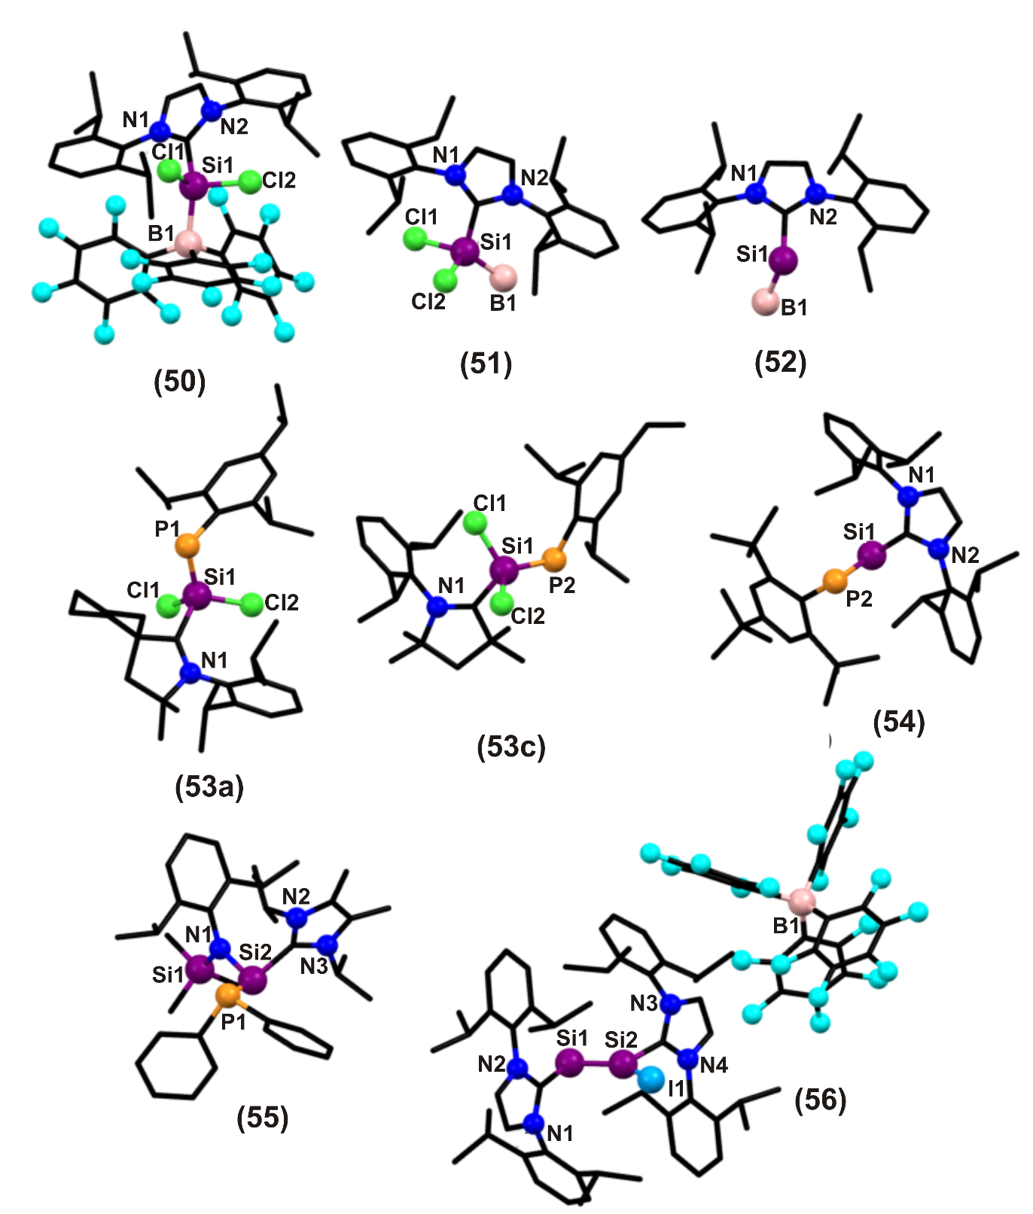
Fig. 9.
The reduction of 51 using LiAlH₄ in the presence of low polarity solvent mixture, toluene/ether furnished Si(II) dihydride adduct (L¹.SiH₂.BH₃) (52) as colorless solid with 55% yield (Scheme 36) []. Based on the crystallographic analyses, the Ccarbene-Si bond distance is 1.928 (15) Å and the Si–B bond distance is 1.992(2) Å. Consistent with the above mentioned crystallographic data, the IR spectrum of 52 exhibited a sharp band at 2096 cm⁻¹ due to coincident ν_{sym} and ν_{asym} Si–H stretching modes, along with diagnostic ν_{B-H} stretching vibrations in the range of 2238 to 2345 cm⁻¹. The ²⁹Si{¹H} and ¹¹B NMR spectrum are obtained as a quartet at δ = -55.6 (¹J_{Si-B} = 46 Hz) and δ ₌ -46.2 (¹J_{B-H} = 93 Hz), respectively. The molecular structure of 52 was confirmed by single crystal X-ray diffraction studies (Figure 9). The C_{Idipp}–Si bond length in 52 is 1.928(15) Å and the adjacent Si–B distance is 1.992(2) Å. The hydrogen atoms bound to Si and B were located in the electron difference map and refined isotropically to expected Si–H and B–H distances.
Scheme 36. Synthesis of L¹SiH₂.BH₃ adduct (52) [79].
The unstable species, dichlorosilylene was previously stabilized by carbene. The lone pair of electrons on the silicon atom of carbene–SiCl₂ can form a coordinate bond with electron deficient elements. Roesky et al., have demonstrated that cAAC analogue of NHC–SiCl₂ possesses singlet diradical character and therefore is isolated in dimeric form. cAAC type ligands are stronger σ donor and π acceptor than NHC and can also stabilize many main group elements’ rare compounds like phosphasilenes. Following that, in 2015, Stalke et al., used these facts to stabilize a phosphinidene with the general formula carbene→SiCl₂→P−Trip (carbene = cyclic alkyl(amino) carbene (cAAC), and NHC (53), (Trip = 2,4,6-triisopropylphenyl)) (Scheme 37) []. The reaction of Trip–P(SiCl₃)₂ with cAAC and KC₈ in 1:2:2 molar ratio in the presence of THF conferred cAAC→SiCl₂→P-Trip (53) at -105 °C {cAAC= Cy–cAAC (53a), Et₂–cAAC (53b), Me₂–cAAC(53c)} (Figure 9). It was obtained as dark blue blocks in n-hexane medium with 45-50% yield. These compounds were stable for months at 0 °C under inert atmosphere. If cAAC is replaced by NHC, the color of the crystals changes to dark red. Decomposition occurs at temperatures above 170 °C (53a) and 165 °C (53b-c). ²⁹Si NMR spectrum shows a doublet at δ = -6.56 (¹J_{Si-P} = 198.4 Hz) for 53a, δ = -7.48 (¹J_{Si-P} = 203.6 Hz) for 53b and δ = -7.89 (¹J_{Si-P} = 195.5 Hz) for 53c. The ³¹P NMR peaks for 53a/b/c are δ = -123.09/-122.30/-123.27, respectively. The ¹³C NMR resonance was observed in a range of δ = 208.05-211.44. The geometry around Si in 53a is distorted tetrahedral. The Si–C_{carbene} approximate bond distance is 1.84 Å. In CAAC stabilized phosphasilenylidene complex 53: NBO analysis and energy decomposition analysis revealed that NBO between Si and P is largely localized at the phosphorus, which can be considered as π-lone pair orbital of P atom that is involved in Si-P π-back-donation (Chart 4). In addition to the σ donation there also exists π back-bonding which suggests partial double bond character of the Si–P bond. In case of NHC stabilized phosphasilenylidene complex 54, the Natural Bond Orbital (NBO) analysis of the complex showed that the molecular orbitals of Si=P double bond is highly localized. The orbital occupancy of both the σ and π orbitals are nearly equal which indicates that there is a strong covalent interaction between Si and P.
Scheme 37. Synthesis of carbene→SiCl₂→P−Ar (53) [80].

Chart 4. A comparison of bonding in 53 and 54.
Until 2014, the compound, silylidynephosphane which features Si=P was very complicated to synthesis. In 2015 Filippou et al., have successfully implemented the Si^{II} chemistry for the synthesis and characterization of a room-temperature stable NHC-stabilized phosphasilenylidene (54). They have chosen 2 and LiP(Mes*)(TMS) (Mes*=2,4,6-tBu₃C₆H₂; TMS=SiMe₃) as promising starting materials and carried out the reaction in presence of fluorobenzene, which afforded the NHC-stabilized phosphasilenylidene (54) as a bright orange air sensitive solid with 39% yield (Scheme 38) []. The product formation is analyzed by ³¹P NMR. Compound 54 is stable at ambient temperature under exclusion of air and moisture for several months. The molecular structure of 54.Et₂O was studied by single crystal X-ray diffraction which revealed that silicon and phosphorus use predominantly their p-orbital for S=P bond formation with a bond length of 2.119(7) Å (Figure 9). The ²⁹Si{¹H} NMR spectrum of 54 in C₆D₆ displays a doublet signal at δ = 267.3 (¹J_{(P,Si)} = 170.4 Hz). The ³¹P{¹H} NMR spectrum of 54 in C₆D₆ shows a strongly de-shielded singlet signal at δ = 402.4 with ²⁹Si satellites (¹J_{(P,Si)} =170.4 Hz, 4.9%). The Si–C_{carbene} bond distance is 1.960(2) Å.
Scheme 38. Synthesis of NHC stabilized phosphasilenylidene (54) [81].
The phosphinoaminosilylene 55 was synthesized in high yield by the reaction of the aminochlorosilylene ArN(SiMe₃)Si(IiPr)Cl with LiPPh₂ as red crystals (Scheme 39) []. Compound 55 has high thermal stability in solutions, but it is found to be extremely air and moisture sensitive. Compound 55 in THF upon exposure to O₂ at −110 °C resulted in an immediate decoloration. The compound has been fully characterized by ¹H, ³¹P, ¹³C, and ²⁹Si NMR spectroscopy, elemental analysis, and X-ray diffraction analysis (Figure 9). The ²⁹Si resonance for the central silicon atom appeared at δ = 4.23 is comparable to most resonances observed for the known NHC-supported silylenes (δ = −8.78 to 10.9). The ¹³C NMR signal for the NHC central carbon atom resonating at δ = 166.25, consistent with those found in the NHC → Si donor-acceptor complexes. The ³¹P NMR spectrum shows a peak at δ = −33.6. The molecular structure of 55 features the silicon center adopting a trigonal-pyramidal geometry, revealing the presence of a stereochemically active lone pair of electrons at the Si(II) atom. The Si2−C16 bond length (1.991(18) Å) is in the reported range for NHC stabilized halosilylenes (1.980(3) and 2.002 (19) Å). The Si2−P1 bond length (2.375(7) Å) is comparable to a Si−P single bond (2.27−2.31 Å).
Scheme 39. Synthesis of NHC stabilized phosphinoaminosilylene (55) [82]
The halide abstraction studies of 13 were carried out by the addition of one equivalent of [Li(Et₂O)_{2.5}]-[B(C₆F₅)₄] to a solution of 13 in fluorobenzene at ambient temperature which was accompanied by a color change from bright to dark red and precipitation of LiI. Iodide abstraction from 13 selectively furnished the disilicon(I) salt [Si₂(I)(Idipp)₂][B(C₆F₅)₄] (56). The product formation was confirmed by NMR spectroscopy of the crude reaction mixture (Scheme 40) [57]. Compound 56 is an extremely air-sensitive solid, which is instantly degraded by air to a colorless powder. It is stable in THF-d₈ solution for several days under strict exclusion of air, and decomposes upon heating in a sealed glass capillary tube under vacuum at 208 °C. The solid-state structure of 56 was determined by single-crystal X-ray diffraction studies (Figure 9). The molecular structure of 56 is composed of well separated [Si₂(I)(Idipp)₂]+ and [B(C₆F₅)₄]_ ions. The two silicon atoms form a planar core with the end-on bonded iodine atom and the two Idipp atoms. The Si–Si bond of 56 is considerably shorter (2.174(9) Å) than the Si–Si single bond of 13 (2.391(9) Å), but lies in the reported range of Si-Si bond lengths. The angle at the two-coordinate Si atom is quite narrow (Si1–Si2–C28 = 96.61(7)°) and compares well with those observed for NHC-stabilized phosphasilenylidene and the NHC-stabilized disilavinylidene. Variable-temperature ¹H, ²⁹Si and ¹³C NMR studies of 56 in THF-d₈ revealed an interesting dynamic process leading to the exchange of the heterotopic Si sites. Quantum chemical calculations suggested that the degenerate isomerization (topomerisation) proceed via a NHC-stabilized disilaiodonium ion.
Scheme 40. Synthesis of NHC-stabilized disilicon(I) salt [Si₂(I)(Idipp)₂][B(C₆F₅)₄] (56) [57].

3.2 Reactions of NHC:SiX₂ (X = Cl , Br, I, R) with transition metal substrates
The first NHC-stabilized silylidyne was synthesized by Filippou et al., in 2010. The reaction of SiArCl(ImMe₄), where Ar = C₆H₃-2,6-Trip₂ (Trip = C₆H₂-2,4,6-iPr₃) (6) and Li[CpMo(CO)₃] at 100 °C in presence of toluene yielded the silylidene intermediate in 51 % yield (Scheme 41) [38a]. The rapid formation of intermediate was monitored by IR spectroscopy. The intermediate was fully characterized, and its molecular structure was determined by single-crystal X-ray diffraction. The silylidene ligand has a trigonal planar coordinated silicon center (sum of angles at Si=357.08°) and it adopts an upright conformation, with the m-terphenyl group pointing towards the cyclopentadienyl ring. The Mo–Si–CAr angle is considerably widened to 145.38° owing to the large steric demand of the m-terphenyl substituent; the CAr–Si–Ccarbene angle is lowered to 100.48°, which reflects the low tendency of silicon for hybridization. ¹H and ¹³C{¹H} NMR spectrum reveals that the intermediate adopts C_{S} symmetric structure in solution. ¹³C{¹H} NMR peak of the C_{carbene} resonating at δ = 165.3 which is similar to that for 6 (δ = 166.7). ²⁹Si{¹H} NMR signal appears in the downfield at δ = 201.8. All these data signify the zwitterionic nature of the intermediate as shown in Scheme 41.
Scheme 41. Reaction of 6 to synthesize silylidyne complex (57) [38a]
Upon refluxing with triarylborane {B(C₆H₄-4-Me)₃} in the presence of o-xylene, the complex intermediate yielded the silylidyne complex triarylborane (57) and a carbene-borane adduct IMe₄.B(C₆H₄-4-Me)₃ (4-Me). 57 was purified by fractional distillation using pentane as solvent and isolated as brick red air sensitive solid with 53% yield. This is an exergonic process. 57 has nearly C_{S} symmetry and it is isostructural with its germanium analogue (Figure 10). Mo–Si–C_{Ar} angle is 173.49(8)° showing nearly linearly coordinated silicon center. The Mo–Si triple bond length is 2.224 (7) Å. The ²⁹Si{¹H} NMR signal appears considerably in the downfield at δ = 320.1 when compared to the intermediate. The IR spectrum in toluene shows 2 ν(CO) peaks at 1859 & 1785 cm⁻¹ for silylidene complex and 1937 & 1875 cm⁻¹ for silylidyne complex which is similar to its germanium analogue (1930 & 1875 cm⁻¹). These results showed that silylidene ligand in the Mo-Si intermediate is weaker π-acceptor ligand than the silylidyne ligand in 57. Also, the silylidyne and germylidyne ligand has similar σ-donor/π-acceptor ratio.
Transition metal supported silylene derivatives were synthesized by Tavčar et al., in 2010. Nickel carbonyl bearing silylene derivatives L¹₂Ni(CO)₂ (58) (Scheme 42) were prepared from the reaction of L¹ with Ni(CO)₄ in 1:2 molar ratio in presence of toluene []. The compound 58 is found to be extremely air- and moisture-sensitive and decomposed immediately when exposed to air. 58 is soluble in solvents like diethyl ether, toluene, and THF. The ²⁹Si{¹H} NMR peak resonates at δ = 43.19 (downfield with respect to L¹, δ =19.06). The ¹H NMR shows three resonance peaks; first is of –CH(CH₃)₂ at δ = 0.96 and 1.51 (L¹; δ = 1.01 and 1.43), second is of –CH(CH₃)₂ at δ = 2.94 (L¹; δ = 2.79) and third is of NCH at δ = 6.23 (L¹; δ = 6.36). The ¹³C NMR confirms the presence of carbonyl group resonating at δ = 202.51. In the IR spectrum, CO-stretching frequencies appear at 1974 cm⁻¹ and 1921 cm⁻¹. The complex 58 was characterized by single-crystal X-ray analysis, NMR and IR spectroscopy, EI-MS spectrometry, and elemental analysis. The silicon atoms in 58 are tetra-coordinate and adopt distorted tetrahedral geometry (Figure 10). In 58 the four sites are occupied by one carbon, two chlorine, and one nickel atom and nickel also displays distorted tetrahedral geometry, but it features a coordination environment of two Si and two C atoms of the carbonyl groups. The Si–Ni bond lengths are 2.196(9) Å and 2.185 (7) Å in 58. This is 0.14 Å (Si11) and 0.16 Å (Si12) shorter than the sum of covalent radii of Si (1.11 Å) and Ni (1.24 Å). This indicate that there is π-back bonding within the Ni–Si bond (Chart 5). A variation in bond angle is also observed.
Scheme 42. Synthesis of L¹₂Ni(CO)₂ (58) [83].

Chart 5. σ bonding and NiSi back bonding in 58.
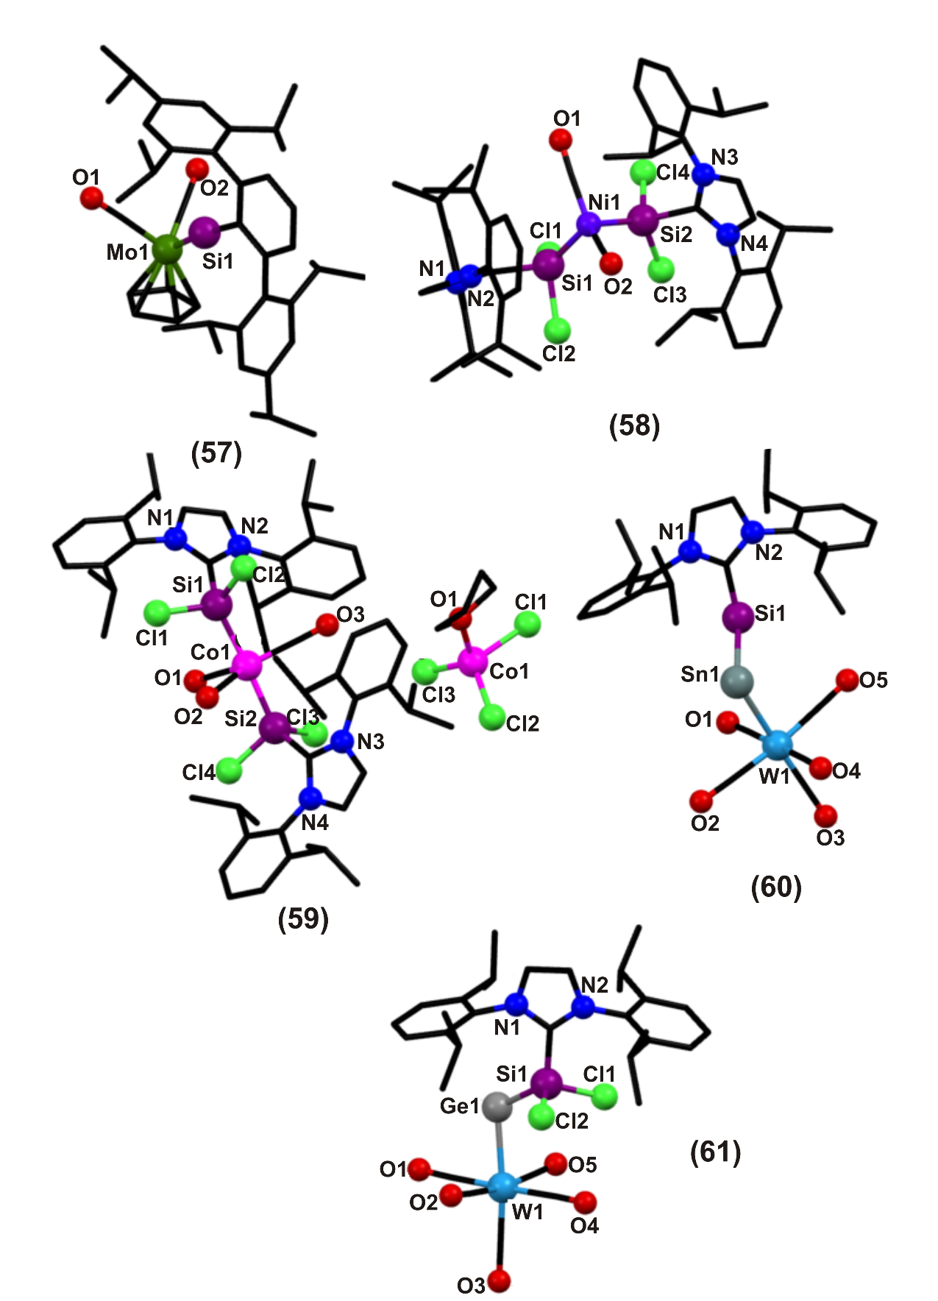
Fig. 10
In the same year, the first cobalt(I) Lewis-base-stabilized silylene complex [Co(CO)₃{SiCl₂(L¹)}₂]⁺[CoCl₃(THF)]⁻ (59) was synthesized as air- and moisture sensitive blue crystals by the reaction of two electron σ-donor ligand SiCl₂(L¹) with Co₂(CO)₈ in toluene medium at room temperature (Scheme 43) []. Compound 59 is found to be soluble in THF but insoluble in benzene and toluene. The reaction shows that 2 functions as coordinate ligand as well as a chlorinating and oxidizing agent. The cationic part [Co(CO)₃{SiCl₂(L¹)}₂]⁺ has C₂ symmetry and has distorted trigonal bipyramidal geometry with CO in the equatorial plane (Figure 10). Si-Co-Si is closely linear having cobalt in +1 formal oxidation state. The anionic part [CoCl₃(THF)]⁻ is pseudotetrahedrally coordinated with Co in +2 formal oxidation state. The Co-Si bond lengths are 2.228(13) Å and 2.228(12) Å which is shorter than the covalently bonded Co-Si. The two silicon centers possess distorted tetrahedral geometry. 59 shows abnormal resonance in the ¹H NMR spectrum at room temperature due to the presence of d⁷ cobalt(II) tetrahedral anion and these resonance are shifted to different extent from δ = +50 at -90 °C and become broader at lower temperature. The ²⁹Si{¹H} NMR spectrum of 59 exhibited a singlet at δ = 44.11 which is 25.05 downfield shifted than 2 (δ =19.06), which demonstrates the ambiphilicity of the Lewis-base-stabilized silylene in 59.
Scheme 43: Synthesis of [Co(CO)₃{SiCl₂(L¹)}₂]⁺ [CoCl₃(THF)]⁻ (59) [84].
NBO analysis of 59 indicates that in NHC-Si-Co-Si-NHC complex one silicon atom forms covalent bond with cobalt whereas the other silicon atom donates it lone pair of electrons (Chart 6). NBO analysis also revealed that the lone pair of electron on silicon is delocalized into the same empty orbital into which the carbonyl lone pair electron is delocalized. Both donation modes offer extra stability to the complex. However, the chemical characterization of the Co-Si bond indicates that both bonds are equivalent.
Chart 6. Bonding representation in 59.
Ethylene is a very important precursor in many reactions but its heavier analogues (R₂E=ER₂; E= Ge, Sn or Pb) are hard to synthesize and stabilize but they are potential precursor in building new inorganic hybrid molecule. They are stabilized by introducing a bulky group. Their bonding conditions are also entirely different than regular olefins; as they can dissociate into two monomeric singlet R₂E: in solution and stays as trans bent geometry in solid state. In this direction, the first stable inorganic ethylene complex H₂SiEH₂ (E= Ge and Sn) was synthesized by Rivard et al., in 2011 []. These H₂E=EH₂ (E= Si-Pb) complexes exists in trans-bent geometries and either of the centre can act as electron donor or acceptor which concludes that their isolation can be done in the presence of suitable Lewis acidic and basic groups. To construct the requisite Si–Ge and Si–Sn linkages, by reacting Roesky’s nucleophilic Si(II) halide adduct 2 with the coordinatively labile tungsten complexes, [(THF)n·ECl₂·W(CO)₅] (E=Ge & Sn); the resulting perhalogenated complex [L¹Cl₂Si-ECl₂.W(CO)₅] (E= Ge & Sn) were isolated in high yield as pale yellow solids. Treatment of previous resulting product with LiAlH₄ or LiBH₄, respectively, led to the installation of hydride functionality onto the Group 14 elements and the formation of the desired inorganic ethylene adducts, [Idipp·H₂Si-EH₂·W(CO)₅] (E=Ge and Sn; 60 and 61) as air and moisture-sensitive solids (Scheme 44 and Figure 10). 51 is thermally more stable than 61, which decomposes even at low temperatures (-30 °C). Conclusive evidence for the formation of the parent hydride adducts 60 and 61 was obtained by X-ray crystallography, NMR and IR spectroscopy, theoretical calculations, and deuterium labeling. The Si–Ge bond distance in 60 is 2.322(14) Å. The C_{carbene}–Si bond length is 1.915(5) Å which is shorter than 2. ¹H NMR resonance appears as second order resonance at δ = 3.73 and 1.90 for SiH₂ and GeH₂, respectively in [D₈]THF, showing that the rotation of SiH₂ and GeH₂ groups is restricted in NMR timescale, making all the hydrides in-equivalent. ²⁹Si{¹H} NMR resonance was detected at δ = -71.9. The IR stretching bands of Si–H appeared in the region 2140 & 2150 cm⁻¹ and that of Ge–H appeared at 1959 cm⁻¹. 61 is nearly isostructural with 60. In both 60 and 61 the tungsten centre occupies quasi octahedral geometries. The IR stretching band for Si–H was found at 2136 cm⁻¹. The Sn–H vibrations were not identified which could be due to their low oscillator strengths. A very distinct NMR data was obtained for 61. The ¹¹⁹Sn{¹H} NMR spectrum shows triplet of triplet at δ = -537 because of coupling between ¹¹⁹Sn nuclei and hydrogen atom of SnH₂ and SiH₂. Theoretical studies on 60 and 61 indicated that there are no multiple bonds between Si and E. Both the dative bonds NHC-Si (C^{δ-}–Si^{δ+}) and E-W (E^{δ-}-W^{δ+}) are highly polarized (Chart 7).
Scheme 44. Synthesis of H₂SiEH₂(60 and 61) [85].

Chart 7. Bonding in 60 and 61.
3 is a very good source of divalent silicon compound which is labile enough for nucleophilic reactions. This property was used by Filippou et al., to make silylidyne complex salt [Cp(CO)Cr=Si(IMe₂iPr₂)₂][B(C₆F₅)₄], which further irreversibly dimerizes to make the dinuclear siloxycarbyne complex [Cp(CO)Cr{(μ-CO)Si((IMe₂iPr₂)₂}₂Cr(CO)Cp][B(C₆F₅)₄]₂ (65) by electrophilic activation of one carbonyl oxygen atom. 3 on reaction with Li[CpCr(CO)₃] in benzene at 80 °C makes NHC-stabilized bromosilylidyne ligand (62) (Scheme 45) []. Similarly, 2 on reaction with Li[CpCr(CO)₃] in benzene at 70 °C gives the chloro congener of 62 i.e. 63 both of them being air sensitive crystalline solids. 62 is dark brown in color whereas 63 is brown air in color. The silicon center in both the compounds is trigonal planar coordinated and uses the hybrid orbital with high p character for σ bonding with Br/Cl. The Cr–Si bond distances are 2.016(9) Å and 2.160(7) Å in 62 and 63, respectively (Figure 11). The Si–Br and Si–C carbene bond distances are 2.273(8) Å and 1.957(3) Å. The IR spectra in fluorobenzene shows two ν(CO) peaks at 1894 & 1809 cm⁻¹ for 62 and 1890 & 1806 cm⁻¹ for 63 showing the presence of an electron rich metal centre with strong metal carbonyl back-bonding. In ²⁹Si NMR 62 and 63 showed singlet at δ = 95.1 and 113.6, respectively, which is shifted to lower field considerably compared to that of 2 (δ = 10.8) or SiX₂(Idipp) (X=Br, δ = 10.9; X=Cl, δ = 19.1).
The reaction of 62 with two equivalents of 1,3-dihydro-4,5-dimethyl-1,3-bis(isopropyl)-2H-imidazole-2ylidene (IMe₂iPr₂) in benzene at 20 °C gives another class of silylidyne 64. It is isolated in 88% yield as a red-brown crystalline air-sensitive solid which decomposes over 166-168 °C. The reaction proceeds via addition-elimination reaction sequence. There is a considerable shift in the ν(CO) absorption band to lower wavenumbers (1797 & 1733 cm⁻¹) in THF because of the presence of two NHC, indicating stronger Cr-CO back-bonding than 62. ²⁹Si NMR spectrum in [D₈]THF appears as a singlet at δ = 17.3 which is at higher field than 62 at δ = 95.1. It has C₁ symmetric minimum structure because of the frozen rotation of NHC at low temperature (Figure 11). The Cr–Si bond distance is 2.252(7) Å. The Si–C_{carbene} bond average bond distance is 1.979 Å. Also the Si–Br bond length is 2.434(6) Å, which is significantly longer, depicting the more polar Si–Br bond. When one equivalent of Li[B(C₆F₅)₄] is added to 64 in fluorobenzene at ambient temperature, LiBr is rapidly precipitated. IR monitoring of this reaction reveals the formation of [Cp(CO)₂Cr=Si(IMe₂iPr₂)₂][B(C₆F₅)₄] with ν(CO) at 1895 & 1821 cm⁻¹, which is considerably higher wavenumber than 64 and is similar to 63. This complex is non-isolable and dimerizes rapidly at -16 °C to furnish insoluble yellow dinuclear siloxycarbyne complex salt 65. It shows only one IR peak for CO ligand at 1860 cm⁻¹, displaying them to be equivalent, and lies in the region expected for terminal CO ligands. The molecular structure of 65 reveals the crystallographic inversion center at the midpoint of the eight-membered metallacycle. The Cr–C bond in 65 (1.717(2) Å) is considerably shorter than the Cr–C bond of the terminal carbonyl ligand (1.803(2) Å). Furthermore, the O–C bond (1.291(2) Å) is considerably longer than that of the terminal carbonyl ligand (O–C 1.178(2) Å). The elongated Si–O bond of 65 (1.749(1) Å) complements the bonding picture of a siloxycarbyne complex with some µ-isocarbonyl character. This is further confirmed by the short Cr–Si bond distance (2.285(6) Å) lying in the expected range.
Scheme 45. Synthesis of halosilylidyne and dinuclear siloxycarbyne complex (62, 63, 64 & 65) using 2 and 3 [86].
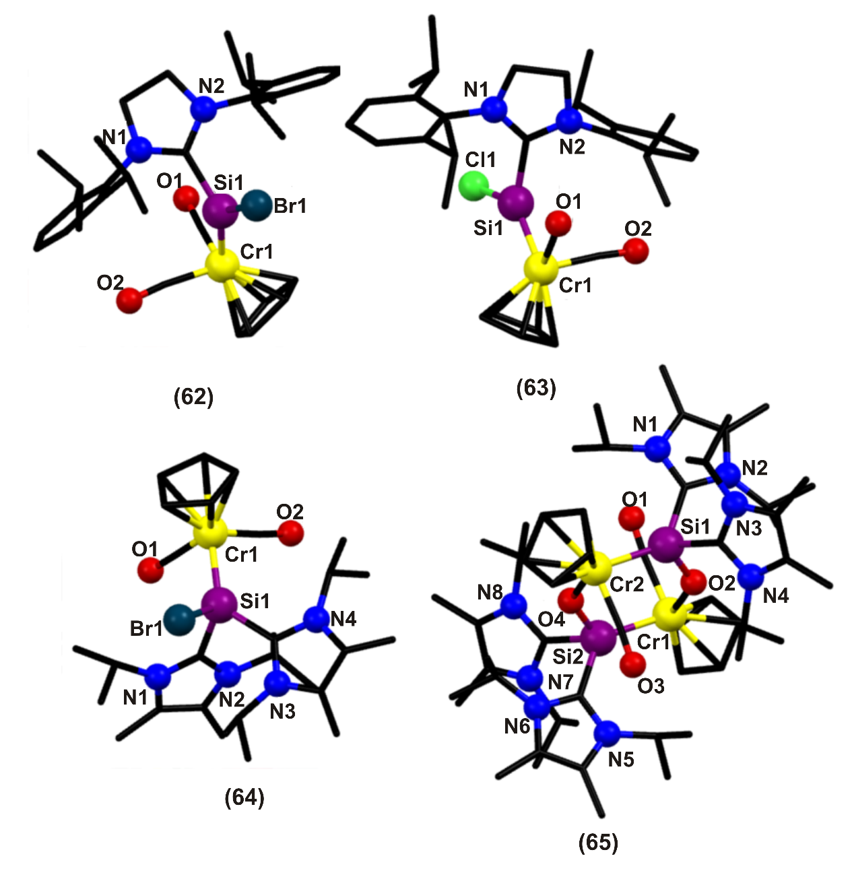
Fig. 11.
The Si(II) dihydride has a great tendency for electron donation. To show this, they combined L¹.SiH₂.BH₃ adduct (52) with THF.W(CO)₅ which readily gave a stable tungsten complex L¹.SiH₂.W(CO)₅ (66) with loss of THF.BH₃ (Scheme 46) [79] in quantitative yield. In the IR spectrum two sharp bands were observed at 2086 cm⁻¹ and 2107 cm⁻¹ corresponding to ν_{sym} and ν_{asym} Si–H stretching modes respectively. The trans CO ligand at tungsten gives characteristic A₁ vibration at 2044 cm⁻¹. DFT studies showed that the Si–W bond is polarized with more electron density at silicon. The Si–C_{carbene} bond distance is 1.928(13) Å and the Si–W bond distance is 2.573(4) Å (Figure 12). DFT studies of 66 identified a dative Idipp-C^{δ-}–Si^{δ+} bond and the SiH₂ groups has considerable hydridic character (H^{δ-}). In the complex the electron density of Si–W bond is moderately polarized towards Si (Chart 8).
Scheme 46. Synthesis of L¹SiH₂.W(CO)₅ complex (66) [79].

Chart 8. Interaction between NHC-Silylene moiety and W(CO)₅ moiety in 66.
The same group latter produced a stable Rh-Silylene complex, trans-[(L¹.SiCl₂)₂Rh(CO)₂]⁺ cis-[Rh(CO)₂Cl₂]⁻ (67) isolated in 87% yield as an orange crystalline solid, by reacting 2 with excess [Rh(CO)₂Cl]₂ in toluene, (Scheme 47) [79]. It is a coordination isomer of [L¹.SiCl₂.Rh(CO)₂Cl]. The ¹³C{¹H} NMR shows two distinct CO peaks displaying two different environment. The average Si-C_{carbene} and Si-Rh bond distances are 1.939(3) Å and 2.361(8) Å, respectively (Figure 12).
Scheme 47. Synthesis of trans-[(L¹.SiCl₂)₂Rh(CO)₂]⁺ cis-[Rh(CO)₂Cl₂]⁻ (67) [79].
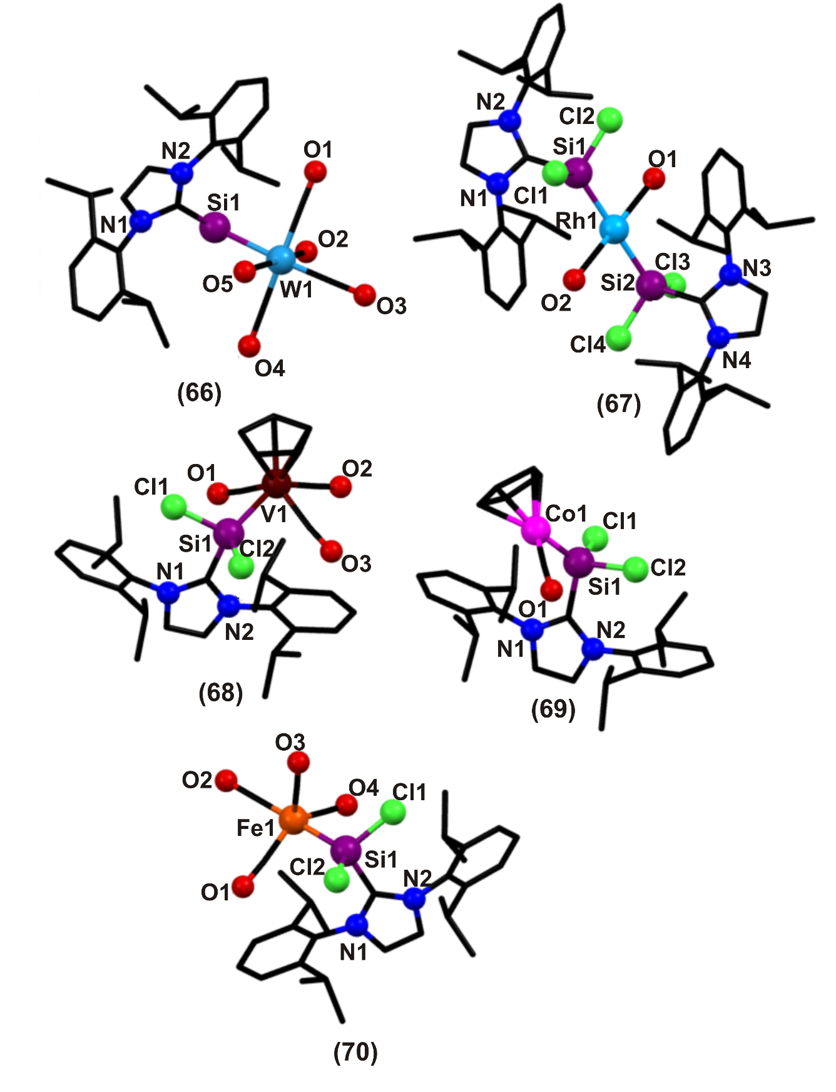
Fig. 12.
Reactions of NHC stabilized dichlorosilylene 2 with (η⁵-C₅H₅)V(CO)₄, (η⁵-C₅H₅)Co(CO)₂, and Fe₂(CO)₉ afforded the dichlorosilylene complexes 68, 69 and 70 in quantitative yield (Scheme 48 and Figure 12) []. Complexes 68, 69 and 70 are crystalline solids which are soluble in common organic solvents and are stable under inert atmosphere. All the compounds were characterized by elemental analysis and multinuclear (¹H, ¹³C, and ²⁹Si) NMR spectroscopy. Molecular structures of 68, 69 and 70 have been confirmed by single crystal X-ray crystallographic studies and refined with non-spherical scattering factors. Complexes 68 and 69 each show a singlet for cyclopentadienyl (C₅H₅) protons. ¹³C{¹H} NMR spectra of 68, 69 and 70 exhibit usual resonances for the 2 ligand. In the ¹³C NMR spectra (in CD₂Cl₂) of 68 and 69, a resonance at δ = 90.78 and 82.17 assigned for each cyclopentadienyl group. Complex 68 exhibits a broad ²⁹Si NMR signal at δ = 88.70 due to the presence of paramagnetic vanadium. Similar broadening can also be seen in the ¹³C{1H} NMR spectrum of 68 for carbonyl groups (δ = 259.20-263.03). Complex 68 features a distorted square-pyramidal geometry defined by the C₅H₅ centroid around the vanadium atom. Silicon is four coordinate and displays a distorted tetrahedral geometry. The coordination environment around vanadium consists of three carbonyl groups, one (η⁵-C₅H₅), and a neutral silylene ligand. The V-Si bond length (2.405(8) Å) is shorter than those observed for vanadium-silyl (2.56 Å) complexes, indicating a contribution of π-back bonding. The Cl-Si-Cl bond angle in 54 (99.63(4) º) is comparable to that in 2 (97.25(6)º). The mean Si-Cl bond length (av 2.119(11) Å) in 54 is slightly shorter than that observed for 2 (av 2.166(16) Å), which may be interpreted as increased Lewis acidity of the silicon due to the σ-electron donation to the vanadium atom.
In 69 complex the cobalt atom assumes distorted trigonal planar coordination geometry defined by the C₅H₅ centroid, the CO ligand, and the silylene ligand 2. The Co-Si bond length is 2.135(5) Å. The C-Si-Co bond angle is 121.23(5)°. The geometry around the iron atom in 70 is distorted trigonal bipyramidal with three equatorial positions occupied by carbonyl groups and each of the two axial positions by a carbonyl group and a silylene ligand. The silicon center is four coordinate and features a distorted tetrahedral geometry. The Si-Fe bond distance in 70 (2.232(13) Å) is comparable to those observed in silylene- iron complexes. The axial Si-Fe-C bond angle is almost linear (177.01(19)°).
Scheme 48. Synthesis of NHC stabilized dichlorosilylene transition-metal complexes of V(I) (68), Co(I) (69), and Fe(0) (70) [87].
The synthesis and characterization of the NHC stabilized dichlorosilylene Group 6 metal complexes {(Idipp)SiCl₂}W(CO)₅ (72), {(Idipp)SiCl₂}₂Cr(CO)₄ (73), and {(Idipp)SiCl₂}₂W(CO)₄ (74) have been reported by Ghadwal et. al. in 2017 [] (Scheme 49). The complexes 72, 73, 74 were synthesized in quantitative yield and have been characterized by elemental analysis and multinuclear (¹H, ¹³C, and ²⁹Si) NMR spectroscopy. Compounds 72, 73 and 74 are pale yellow solids that are stable under an inert gas atmosphere. ¹H NMR spectra of 72, 73, and 74 exhibit well-resolved resonances for the Idipp ligand, which appear in almost similar regions for all three complexes. The ²⁹Si{¹H} NMR signals of 73 (δ = 64.57), 74 (δ = 24.84), and 72 (δ = 26.87) are quite distinct and each shows a downfield shift compared to that of the silylene 2 (δ = 19.06 in C₆D₆). The ²⁹Si NMR signal of 72 (¹J_{W–Si} = 164.2 Hz) and 4-W (¹J_{W–Si}= 165.4 Hz) is escorted by the corresponding ¹⁸³W satellite signals. In order to shed light on the reaction pathways, the geometries and energies of the molecules were computed by quantum chemical calculations using density functional theory (DFT). Structures of the compound 73 and 74 have been determined by single-crystal X-ray diffraction analyses. The central metal atom of each of 73 and 74 is hexa-coordinated, featuring two silylene ligands at the trans-axial positions, the four CO ligands occupies the equatorial positions (Figure 13). The dichlorosilylene (2) functions as a two electron σ-donor ligand, featuring a four-fold coordinated silicon atom that is bonded with two chlorides, one NHC, and one metal (Cr or W) atom. The Si–M–Si bond angle of 73 (177.76(3)°) and 74 (176.41(7)°) is almost linear. The Si–Cl and Si–C bond lengths of 73 and 74 are comparable with other metal complexes featuring 2 as a ligand.
Scheme 49. Synthesis of NHC stabilized dichlorosilylene Group 6 metal complexes, 71-74 [88].
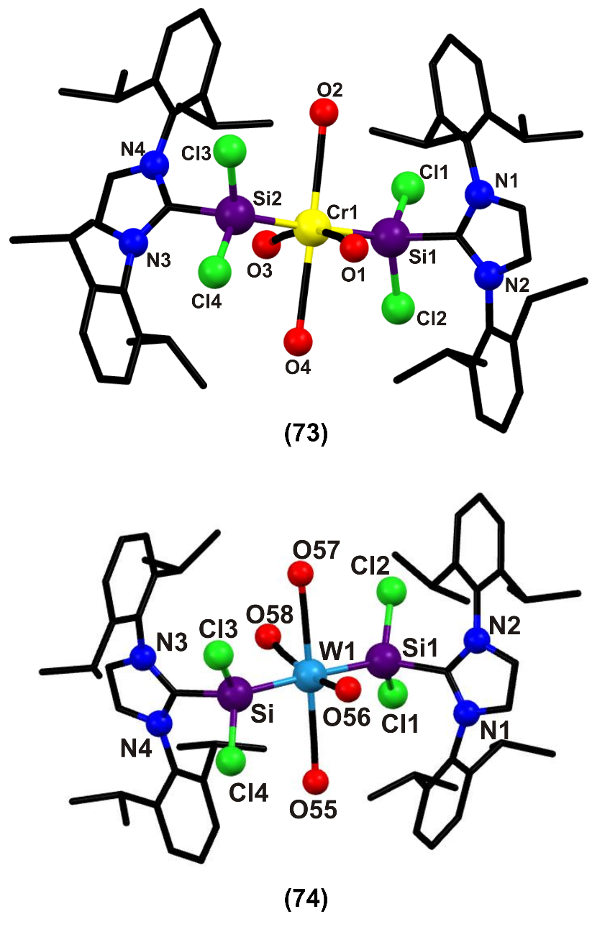
Fig. 13.
Filippou et al., reported a novel method for the preparation of SiCp*² (75) (Cp* =C₅Me₅) in which NHC-stabilized halosilylene [NHC-SiX₂, (X = Cl, Br)] was treated with 2 equiv of KCp*. The selective protonolysis of 75 with [H(Et₂O)₂]⁻[B(C₆F₅)₄] yielded [Si(η⁵-Cp*)][B(C₆F₅)₄] (76) in high yield. Reaction of 76 with the tailored metallate Na[TpMeMo(CO)₂(PMe₃)] afforded the silylidyne complex [TpMe(CO)₂MoSi(η³-Cp*)] (77; TpMe = κ3-N,N′,Nʺ-hydridotris(3,5-dimethyl-1-pyrazolyl)-borate) 77 as an analytically pure, highly air-sensitive, orange solid in 49% yield []. Compound 77 was characterized by single crystal X-ray diffraction and spectroscopic studies. In compound 77 the Mo−Si bond length is 2.309(4) Å which is considerably shorter than the Mo−Si single bonds of silyl complexes 2.56 Å, Mo=Si bonds of silylidene complexes, 2.287(1)−2.3872(7) Å) and is only slightly larger than the Mo≡Si bond of the reddish-orange arylsilylidyne complex [TpMe(CO)₂Mo≡Si-Tbb] 2.261(9). DFT calculations support the unique bonding situation in 77 which features a Mo−Si bond with partial triple bond character and a η³-coordinated Cp* which is attached to silicon.
Scheme 50: Synthesis of Silylidyne Complex [TpMe(CO)₂MoSi(η³‑C₅Me₅)] 77.
Fig. 14
4. Bonding in NHC stabilized silylenes and their complexes
An extensive analysis on the bonding situation between Si(II) and C_{carbene} have been investigated. Based on the reported outcome, we have correlated the impact of carbenes and substituents on the silicon atom.
4.1. Type of carbene: NHC-silylene stabilized phosphinidenes vs cAAC-silylene stabilized phosphinidenes
In compounds 53a and 53c, the Si-C_{carbene} bond length is 1.945(2) Å and 1.944(2) A, respectively (Scheme 37), [80] which is longer compared to that in cAAC stabilized silylene [1.8423(17)-1.8424(17) Å]. In NHC-silylene stabilized phosphinidenes (53d) (Scheme S1), the Si-C_{carbene} bond length is 1.928(3) Å, which is shorter compared to that in NHC-stabilized silylene (1.985(4) Å). The UV-vis spectra of all these complexes were measured and complexes 53a, 53b and 53c showed absorption around ~460 nm and ~660 nm, whereas 53d showed absorption around 475 nm and no absorption at ~660 nm. The absorption at ~660 nm in 53a-c is due to a strong intramolecular charge transfer from π_{Si=P}→π*_{cAAC,} which in turn leads to longer Si-C_{carbene} bond compared to that in similar cAAC-silylene. The absence of absorption at ~660 nm in NHC-silylene stabilized phosphinidene clearly indicates that there is no intramolecular charge transfer similar to that observed in cAAC. This is due to the fact that the HOMO-LUMO energy gap in NHC is higher compared to that in cAAC [supplementary information ref 80].

Chart 9: Picture depicting intramolecular charge transfer (ICT) in 53a [80]

In IDipp stabilized chlorosilylenes, 2 [33] the Si-C_{carbene} bond length is 1.985(4) Å, in bromo analogue, 4 [34] it is 1.989(3) Å and in iodo analogue, 9 [55] it is 1.997(4) Å. In SIDipp stabilized chlorosilylene, 4a [86] the Si-C_{carbene} bond length is 2.012 Å. In 4,5-dimethyl-1,3-bis(isopropyl)imidazole-2-ylidene stabilized chlorosilylene, 7 [41b] the Si-C_{carbene} bond length is 2.002(19) Å. The difference in bond length in compounds 2, 4 and 9 is due to fact that the electronegativity of the halogen atom decreases along the group, chlorine being more electronegative tend to pull the electrons towards it whereas iodine the least electronegative among the group has less tendency to pull the electron cloud. The observed bond length difference in complexes 4 and 4a is because in 4 the electron density on carbene carbon is delocalized ,whereas in 4a it is not delocalized.

4.2. Effect of substitution on silicon atom
In adduct 58, [83] the Si-C_{carbene} bond length is 1.985(2) Å and 2.002(2) Å, which is nearly equal to or slightly longer than that in the silylene. This clearly indicates that Si(II) became a strong σ donor and poor π acceptor. However, in compound 59, [84] the mean Si-C_{carbene} bond length is 1.948(4) Å, which is significantly shorter than those observed in SiCl₂(IPr) [1.985(4) Å], due to the increased Lewis acidity of the silicon center (σ-electron donation from Lewis base- stabilized silylene to the cobalt atom). The Si-C_{carbene} bond length in 60 [85] is 1.915(5) Å (Sn analogue 1.912 Å), which is shorter than that in SiCl₂(IPr) [1.985(4) Å]. The decrease in bond length indicates that there is a formal dative bond present in both the adducts.
The Si-C_{carbene} bond length in IDipp-chlorosilylene.BR₃ adducts 50 and 51 as well as IDipp-silylene.BR₃ 52 is 1.965(5) Å [77], 1.937(2) Å [78] and 1.9284(15) [79] Å, respectively. The observed bond length is less than that in IDipp-chlorosilylene 1.985(4) Å. Topological studies on complex 50 also revealed that the C-Si and Si-B bonds are of considerably different quality. The C-Si bond is very polar, which indicates that NHC is a hard ligand whereas the Si-B bond is much more covalent (B(C₆F₅)₃ being an ideal Lewis acid is capable of forming a dative bond) indicating that the silylene is a soft donor. The bond critical point (BCP) analysis at the C-Si bond is located much closer to the silicon atom (0.77) than the BCP at the Si-B bond (1.26). In compound 51, the Si-C_{carbene} bond length is 1.965(2) Å, whereas in compound 52 the Si-C_{carbene} bond length is 1.9284(15) Å. The increase in bond length observed in 51 could be due to the fact that chlorine being more electronegative makes the bond longer, whereas in 52 hydrogen being more electropositive makes the bond shorter.
The Si-C_{carbene} bond distances in 29 [65] (1.917(5) Å), 30 [65] (1.953(2) Å), and 31 [65] (1.938(2) Å) are shorter than that of the silylene (1.985(4) Å). In molecule 54, the Si-C distance is 1.960(2) Å, which is only slightly less than that of the silylene whereas the Si=P bond is much more covalent i.e. the Si=P bond is stronger than Si-C_{carbene} bond, which indicates that this adduct can be used as phosphasilenylidene transfer reagent in presence of suitable IDipp trapping agent.
The bond lengths of the compounds/complexes considered for the above discussion are tabulated in Table S1. Thus, the Si-C_{carbene} bond length depends to a greater extent on the type of carbene, the substitution on silicon, the coordination number of silicon and to a lesser extent on the substituent on the nitrogen atom of the carbene. As we do not have enough examples to consolidate the bonding nature between Si(II) and carbene carbon, the further investigation in this direction could help in better way to understand the bonding situation.

5. Summary and Outlook
The synthesis and diverse properties of NHC stabilized halosilylenes have been discussed in this review. Despite the manifestation of several landmark papers hinting at the massive potential of NHC stabilized metal derivatives, it was not until the year 2009 that a drastic increase in the chemistry of NHC stabilized halosilylenes began. Eleven new NHC stabilized halosilylenes have been synthesized and structurally characterized during last nine years. The NHC ligand holds the key role on the stabilization of halosilylenes. Besides, NHC can also be consider as potential ligand for liberating (:SiX₂) from NHC stabilized halosilylenes under suitable reaction conditions. The bond formed is yet facile enough to break for the use of monomeric SiX₂ under specific reaction conditions. The lone pair of electron on silicon is yet available for further donation and is stereochemically active, which results in its reactivity. This ambiphilicity leads to its extensive reactivity and ability to form low-valent silicon(II) compounds with considerable stability. Therefore, the halosilylenes serves a widespread role in the field of inorganic as well as organic synthesis. Thus, the reaction between NHC stabilized halosilylenes and suitable organic reactants gave twenty fifteen new structurally characterized low valent silicon species with different thermal stabilities. In addition, thirty-three new low valent halosilylene stabilized main group metal derivatives and sixteen new low valent halosilylene stabilized transition metal derivatives have been isolated and structurally characterized. Nevertheless, halosilylene stabilized rare-earth metal derivatives are not reported yet. Hence, NHC stabilized halosilylenes provides access to many silicon analogues of carbon compounds such as silylidenes, silylidynes (π bonds), silallenes, etc. with ease at normal conditions. Future endeavors might include the exploration of many more unknown useful low-valent silicon compounds and precursors, which in themselves are a rarity in the literature. The development of new revolution in halosilylene chemistry will no doubt continue to endow with new challenges; yet, designing the wide array of halosilylene stabilized transition metal or rare earth metal or main group metal derivatives that are more stable and active in catalysis as a major focus.

6. Acknowledgement
GP gratefully acknowledge the Council of Scientific and Industrial Research (No: 01(2884)/17/EMR-II) for financial support. VK thank DST-WOS-A (WOS-A/CS-65/2016) for fellowship. NM thank DST-NPDF (PDF/2016/001834) for fellowship.

7. References

[] P.P. Gaspar, R. West in the Chemistry of Organic Silicon Compounds, Vol. 2 (Eds.: Z. Rappoport, Y. Apeloig), Wiley, Chichester, UK, (1998) 2463–2568.
[] P.P. Gaspar in Reactive Intermediates, Vol. 2 (Eds.: M. Jones, Jr., R. A. Moss), Wiley- Interscience, New York, (1981) 335–385.
[] Y.N. Tang in Reactive Intermediates, Vol. 2 (Ed.: R.A. Abramovitch), Plenum, New York, (1982) 297–366.
[] A.G. Moiseev, W.J. Leigh, J. Am. Chem. Soc. 128 (2006) 14442–14443.
[] E. Hengge, D. Kovar, Z. Anorg. Allg. Chem. 458 (1979) 163–167.
[] J.R. Koe, D.R. Powell, J.J. Buffy, S. Hayase, R. West, Angew. Chem. 110 (1998) 1514- 1515; Angew. Chem. Int. Ed. 37 (1998) 1441–1442.
[] (a) N. Tokitoh, W. Ando in Reactive Intermediate Chemistry (Eds: R.A. Moss, M.S. Platz, M. Jones, Jr.) John Wiley & Sons, (2004) 651-715 (b) Y. Mizuhata, T. Sasamori, N. Tokitoh. Chem. Rev. 109 (2009) 3479–3511 (c) W.P. Neumann, Chem. Rev. 91 (1991) 311–334.
[] O. Kühl, Mini Rev. Org. Chem. 7 (2010) 324–334.
[] G. He, O. Shynkaruk, M.W. Lui, E. Rivard, Chem. Rev. 114 (2014) 7815−7880.
[] A.J. Arduengo, R.L. Harlow, M. Kline, J. Am. Chem. Soc. 113 (1991) 361–363.
[] N-Heterocyclic Carbenes, From Laboratory Curiosities to Efficient Synthetic Tools; Diez-Gonzalez, S., Ed.; Royal Society of Chemistry: London, (2011); RSC Catalysis Series.
[] S. Díez-Gonzalez, N. Marion, S.P. Nolan, Chem. Rev. 109 (2009) 3612−3676.
[] M.C. Jahnke, F.E. Hahn, Top. Organomet. Chem. 30 (2010) 95−129.
[] F. Glorius, Top. Organomet. Chem 21 (2007) 1−20.
[] N-Heterocyclic Carbenes in Synthesis; S.P. Nolan, Ed.; Wiley-VCH: Weinheim, Germany, (2006).
[] (a) Carbene Chemistry; G. Bertrand, Ed.; Marcel Dekker: New York, (2002); (b) G. Prabusankar, A. Sathyanarayana, P. Suresh, C.N. Babu, K. Srinivas and B.P.R. Metla, Coord. Chem. Rev. 269 (2014) 96–133; (c) D. Paul, F. Heins, S. Krupski, A. Hepp, C.G. Daniliuc, K. Klahr, J. Neugebauer, F. Glorius, F.E. Hahn, Organometallics 36 (2017) 1001–1008.
[] M. Denk, R. Lennon, R. Hayashi, R.West, A.V. Belyakov, H.P. Verne, A. Haaland, M. Wagner, N. Metzler, J. Am. Chem. Soc. 116 (1994) 2691–2692.
[] R.L. Jenkins, A.J. Vanderwielen, S.P. Ruis, S.R. Gird, M.A. Ring, Inorg. Chem. 12 (1973) 2968–2972.
[] E.E. Siefert, R.A. Ferrieri, O.F. Zeck, Y.-N. Tang, Inorg. Chem. 17 (1978) 2802–2805.
[] J. Heinicke, B. Gehrhus, S. Meinel, J. Organomet. Chem. 474 (1994) 71–82.
[] H. Bock, M. Kremer, M. Dolg, W. Preuss, Angew. Chem., Int. Ed. Engl. 9 (1991) 1186– 1188.
[] C.-W. So, H.W. Roesky, J. Mugull, R. B. Oswald, Angew. Chem. 118 (2006) 4052- 4054; Angew. Chem. Int. Ed. 45 (2006) 3948-3950.
[] V.M. Schmeisser, P. Voss, Z. Anorg. Allg. Chem. 334 (1964) 50–56.
[] V.P.W. Schenk, H. Bloching, Z. Anorg. Allg. Chem. 334 (1964) 57–65.
[] (a) P. Jutzi, U. Holtmann, H. Bogge, A. Muller, J. Chem. Soc., Chem. Commun. (1988) 305–306; (b) R. Pietschnig, R. West, D.R. Powell, Organometallics 19 (2000) 2724– 2729.
[] P. Jutzi, U. Holtmann, D. Kanne, R. Blom, R. Gleiter, I. Hyla-Kryspin, Chem. Ber. 122 (1989) 1629–1639.
[] (a) P. Jutzi, A. Mohrke, Angew. Chem., Int. Ed. Engl. 28 (1989) 762–763; (b) P. Jutzi, D. Kanne, C. Kriiger, Angew. Chem. Int. Ed. Engl. 25 (1986) 164.
[] P. Jutzi, In the Chemistry of Organic Silicon Compounds; Z. Rappoport, Apeloig, Y., Eds.; John Wiley & Sons: Chichester, U.K., (1998) Vol. 2, Chapter 36.
[] M. Kira, S. Ishida, T. Iwamoto, C. Kabuto, J. Am. Chem. Soc. 121 (1999) 9722–9723.
[] (a) M. Denk, R.K. Hayashi, R. West, J. Am. Chem. Soc. 116 (1994) 10813–10814; (b) M. Haaf, A. Schmiedl, T. Schmedake, D.R. Powell, A.J. Millevolte, M. Denk, R. West, J. Am. Chem. Soc. 120 (1998) 12714–12719.
[] (a) R. West, M. Denk, Pure Appl. Chem. 68 (1996) 785–788; (b) T.A. Schmedake, M. Haaf, Y. Apeloig, T. Muller, S. Bukalov, R. West, J. Am. Chem. Soc. 121 (1999) 9479– 9480.
[] (a) B. Gehrhus, M.F. Lappert, J. Heinicke, R. Boese, D. Blaser, J. Chem. Soc. Chem. Commun. (1995) 1931–1932; (b) B. Gehrhus, M.F. Lappert J. Organomet. Chem. 617– 618 (2001) 209–223; (c) B. Gehrhus, P.B. Hitchcock, M.F. Lappert, Organometallics 16 (1997) 4861–4864; (d) B. Gehrhus, P.B. Hitchcock, M.F. Lappert, Organometallics 17 (1998) 1378–1382; (e) B. Gehrhus, P.B. Hitchcock, M.F. Lappert, H. Maciejewski, Organometallics 17 (1998) 5599–5601.
[] R.S. Ghadwal, H.W. Roesky, S. Merkel, J. Henn, D. Stalke, Angew. Chem. 121 (2009) 5793–5796; Angew. Chem. Int. Ed. 48 (2009) 5683–5686.
[] (a) A. C. Filippou, O. Chernov, G. Schnakenburg, Angew. Chem. 121 (2009) 5797–5798; Angew. Chem. Int. Ed. 48 (2009) 5687–5690 (b) A. J. Arduengo, R. Krafczyk, R. Schmutzler Tetrahedron 55 (1999) 14523-l 4534.
[] M. Haaf, T.A. Schmedake, R. West, Acc. Chem. Res. 33 (2000) 704–714.
[] N. J. Hill, R. West, J. Organomet. Chem. 689 (2004) 4165–4183.
[] (a) B. Blom, D. Gallego, M. Driess, Inorg. Chem. Front. 1 (2014) 134–148 (b) W.M. Boesveld, B. Gehrhus, P.B. Hitchcock, M.F. Lappert, P. von R. Schleyer, Chem. Commun. (1999) 755–756 (c) A.G. Brook, S.C. Nyburg, F. Abdesahen, B. Gutekunst, G. Gutekunst, R. Krishna, M.R. Kallury, Y.C. Poon, Y.-M. Chang, W. Wong-Ng, J. Am. Chem. Soc. 104 (1982) 5667–5672 (d) N. Wiberg, G. Wagner, J. Riede, G. Müller, Organometallics 6 (1987) 32–35 (e) D. Himmel, I. Krossing, A. Schnepf, Angew. Chem. Int. Ed. 53 (2014) 370-374 (f) G. Frenking, Angew. Chem. Int. Ed. 53 (2014) 6040-6046 (g) D. Himmel, I. Krossing, A. Schnepf, Angew. Chem. Int. Ed. 53, 2014, 6047-6048.
[] (a) A.C. Filippou, O. Chernov, K.W. Stumpf, G. Schnakenburg, Angew. Chem. 122 (2010) 3368–3372; Angew. Chem. Int. Ed. 49 (2010) 3296–3300 (b) A.C. Filippou, B. Baars, O. Chernov, Y.N. Lebedev, G. Schnakenburg Angew. Chem. 126 (2014) 576– 581; Angew. Chem. Int. Ed., 53 (2014) 565–570.
[] Y. Wang, Y. Xie, P. Wei, R.B. King, H.F. Schaefer, P.v.R. Schleyer, G.H. Robinson, Science 321 (2008) 1069–1071.
[] Y. Xiong, S. Yao, M. Driess, J. Am. Chem. Soc. 131 (2009) 7562–7563.
[] (a) A.C. Filippou, O. Chernov, B. Blom, K. W. Stumpf, G. Schnakenburg, Chem. Eur. J. 16 (2010) 2866–2872 (b) H. Cui, C. Cui, Dalton Trans. 40 (2011) 11937–11940.
[] C.J. Carmalt, A.H. Cowley, Adv. Inorg. Chem. 50 (2000) 1–32.
[] N. Kuhn, A. Al-Sheikh, Coord. Chem. Rev. 249 (2005) 829–857.
[] C.E. Willans, in: J.S. Ian, J.M. Fairlamb, Lynam (Eds.), Organometalic Chemistry, vol. 36, Springer, The Royal Society of Chemistry, 2010, p. 1.
[] C.D. Martin, M. Soleilhavoup, G. Bertrand, Chem. Sci. 4 (2013) 3020.
[] L. Zhao, M. Hermann, N. Holzmann, G. Frenking, Coord. Chem. Rev. 344 (2017) 163– 204.
[] Y. Wang, G.H. Robinson, Dalton Trans. 41 (2012) 337–345.
[] Y. Wang, G.H. Robinson, Inorg. Chem. 50 (2011) 12326–12337.
[] H.W. Roesky, J. Organomet. Chem. 730 (2013) 57–62.
[] S. Ishida, T. Iwamoto, Coord. Chem. Rev. 314 (2016) 34–63.
[] (a) S. S. Sen, H. W. Roesky, Chem. Commun., 54 (2018) 5046-5057; (b) R. Wolf, W. Uhl, Angew. Chem. Int. Ed. 48 (2009) 6774-6776; (c) D. Martin, M. Melaimi, M. Soleilhavoup, G. Bertrand, Organometallics 30 (2011) 5304-5313; (d) A. Sidiropoulos, C. Jones, A. Stasch, S. Klein, G. Frenking, Angew. Chem. Int. Ed. 48 (2009) 9701-9704; (e) H. W. Roesky, S. Khan, Chem. Eur. J. DOI: 10.1002/chem.201801672.
[] N. Kuhn, T. Kratz, D. Blaser, R. Boese, Chem. Ber. 128 (1995) 245–250.
[] K.C. Mondal, H.W. Roesky, M.C. Schwarzer, G. Frenking, I. Tkach, H. Wolf, D. Kratzert, R. H. Irmer, B. Niepçtter, D. Stalke, Angew. Chem. Int. Ed. 52 (2013) 1801– 1805.
[] A.P Singh, P.P. Samuel, K.C. Mondal, H.W. Roesky, N.S. Sidhu, B. Dittrich, Organometallics 32 (2013) 354–357.
[] A.C. Filippou, Y.N. Lebedev, O. Chernov, M. Straßmann, G. Schnakenburg, Angew. Chem.125 (2013) 7112 –7116; Angew. Chem. Int. Ed. 52 (2013) 6974–6978.
[] Y. Xiong, S. Yao, S. Inoue, J.D. Epping, M. Driess, Angew. Chem. Int. Ed. 52 (2013) 7147–7150.
[] M.I. Arz, D. Geiß, M. Straßmann, G. Schnakenburg, A. C. Filippou, Chem. Sci. 6 (2015) 6515–6524.
[] Y. Li, Y.-C. Chan, B.-X. Leong, Y. Li, E. Richards, I. Purushothaman, S. De, P. Parameswaran, C.-W. So, Angew. Chem. Int. Ed. 56 (2017) 7573–7578.
[] K.C. Mondal, H.W. Roesky, B. Dittrich, N. Holzmann, M. Hermann, G. Frenking, A. Meents, J. Am. Chem. Soc. 135 (2013) 15990–15993.
[] K.C. Mondal, H.W. Roesky, M.C. Schwarzer, G. Frenking, B. Niepoetter, H. Wolf, R. Herbst-Irmer, D. Stalke, Angew. Chem. Int. Ed. 52 (2013) 2963–2967; Angew. Chem. 125 (2013) 3036–3040.
[] D. Lutters, C. Severin, M. Schmidtmann, T. Müller, J. Am. Chem. Soc. 138 (2016) 6061–6067.
[] Y. Li, Y.-C. Chan, Y. Li, I. Purushothaman, S. De, P. Parameswaran, C.-W. So, Inorg. Chem. 55 (2016) 9091–9098.
[] R.S. Ghadwal, S.S. Sen, H.W. Roesky, M. Granitzka, D. Kratzert, S. Merkel, D. Stalke Angew. Chem. Int. Ed. 49 (2010), 3952–3955.
[] R.S. Ghadwal, S.S. Sen, H.W. Roesky, M. Granitzka, S. Merkel, D. Stalke, J. Am. Chem. Soc. 132 (2010) 10018–10020.
[] R.S. Ghadwal, S.S. Sen, H.W. Roesky, C. Schulzke, M. Granitzka, Organometallics 29 (2010) 6329–6333.
[] R.S. Ghadwal, S.S. Sen, H.W. Roesky, K. Propper, B. Dittrich, S. Klein, and G. Frenking, Angew. Chem. Int. Ed. 50 (2011) 5374–5377.
[] H. Tanaka, S. Inoue, M. Ichinohe, M. Driess, A. Sekiguchi, Organometallics 30 (2011) 3475–3478.
[] (a) S.M. Ibrahim Al-Rafia, R. McDonald, M.J. Ferguson, E. Rivard, Chem. Eur. J. 18 (2012) 13810–13820 (b) M. I. Arz, D. Hoffmann, G. Schnakenburg, A. C. Filippou Z. Anorg. Allg. Chem. 642 (2016) 1287–1294.
[] R.S. Ghadwal, R. Azhakar, H.W. Roesky, K. Propper, B. Dittrich, C. Goedecke, G Frenking, Chem. Commun. 48 (2012) 8186–8188.
[] Y. Xiong, S. Yao, S. Inoue, E. Irran, M. Driess, Angew. Chem. Int. Ed. 51 (2012) 10074– 10077.
[] H. Cui, B. Ma, C. Cui, Organometallics 31 (2012) 7339–7342.
[] P.P. Samuel, R. Azhakar, R.S. Ghadwal, S.S. Sen, H.W. Roesky, M. Granitzka, J.Matussek, R.Herbst-Irmer, D. Stalke, Inorg. Chem. 51 (2012) 11049–11054.
[] (a) K.C. Mondal, P.P. Samuel, M. Tretiakov, A.P. Singh, H.W. Roesky, A.C. Stuckl, B. Niepotter, E. Carl, H. Wolf, R. Herbst-Irmer, D. Stalke, Inorg. Chem. 52 (2013) 4736– 4743 (b) P. Ghana, M. I. Arz, U. Das, G. Schnakenburg, A. C. Filippou Angew. Chem. Int. Ed. 54 (2015) 9980–9985.
[] A. Bondi, J. Phys. Chem. 68 (1964) 441–451.
[] Y.N. Lebedev, U. Das, O. Chernov, G. Schnakenburg, A.C. Filippou, Chem. Eur. J. 20 (2014) 9280–9289.
[] S.M.I. Al-Rafia, A.C. Malcolm, R. McDonald, M. J. Ferguson, E. Rivard, Chem. Commun. 48 (2012) 1308–1310.
[] R.S. Ghadwal, H.W. Roesky, S. Merkel, D. Stalke, Chem. Eur. J. 16 (2010) 85–88.
[] R. Azhakar, G. Tavcar, H.W. Roesky, J. Hey, D. Stalke, Eur. J. Inorg. Chem. (2011) 475–477.
[] S.M.I. Al-Rafia, A.C. Malcolm, R. McDonald, M.J. Ferguson, E. Rivard, Chem. Commun. 48 (2012) 1308–1310.
[] S. Roy, P. Stollberg, R.H. Irmer, D. Stalke, D.M. Andrada, G. Frenking, H.W. Roesky, J. Am. Chem. Soc. 137 (2015) 150–153.
[] D. Geiß, M.I. Arz, M. Straßmann, G. Schnakenburg, A.C. Filippou, Angew. Chem. Int. Ed. 54 (2015) 2739–2744.
[] H. Cui, J. Zhang, Y. Tao, C. Cui, Inorg. Chem. 55 (2016) 46−50.
[] G. Tavcar, S.S. Sen, R. Azhakar, A. Thorn, H.W. Roesky, Inorg. Chem. 49 (2010) 10199–10202.
[] J. Li, S. Merkel, J. Henn, K. Meindl, A. Doring, H.W. Roesky, R.S. Ghadwal, D. Stalke, Inorg. Chem. 49 (2010) 775–777.
[] S.M. Ibrahim Al-Rafia, A.C. Malcolm, R. McDonald, M.J. Ferguson, E. Rivard, Angew. Chem. Int. Ed. 50 (2011) 8354–8357.
[] A.C. Filippou, O. Chernov, G. Schnakenburg, Chem. Eur. J. 17 (2011) 13574–13583.
[] R. S. Ghadwal, R. Azhakar, K. Propper, J.J. Holstein, b. Dittrich, H.W. Roesky, Inorg. Chem. 50 (2011) 8502–8508.
[] R. S. Ghadwal, D. Rottschäfer, D.M. Andrad, G.Frenking, C.J. Schürmanne, H. G. Stammler, Dalton Trans. 46 (2017) 7791–7799.
[] P. Ghana, M. I. Arz, G. Schnakenburg, M Straßmann, A. C. Filippou Organometallics, 37 (2018) 772-780. Fig. 1. Molecular structures of 1, 2 and 4. Hydrogen atoms have been omitted for clarity. Fig. 2. Molecular structures of 6-10. Hydrogen atoms have been omitted for clarity. Fig. 3. Molecular structures of 12-14 and 18-21. Hydrogen atoms have been omitted for clarity. Fig. 4. Molecular structures of 22-28. Hydrogen atoms have been omitted for clarity. Fig. 5. Molecular structures of 29-31. Hydrogen atoms have been omitted for clarity. Fig. 6. Molecular structures of 33-39 and 41-43. Hydrogen atoms have been omitted for clarity. Fig. 7. Molecular structures of 44 and 45. Hydrogen atoms have been omitted for clarity. Fig. 7a. Molecular structures of 45a and 45b. Hydrogen atoms have been omitted for clarity Fig. 8. Molecular structures of 46-49. Hydrogen atoms have been omitted for clarity. Fig. 9. Molecular structures of 50-52, 53a, 53c, and 54-56. Hydrogen atoms have been omitted for clarity. Fig. 10. Molecular structures of 57-61. Hydrogen atoms have been omitted for clarity. Fig. 11. Molecular structures of 62-65. Hydrogen atoms have been omitted for clarity. Fig. 12. Molecular structures of 66-70. Hydrogen atoms have been omitted for clarity. Fig. 13. Molecular structures of 73 and 74. Hydrogen atoms have been omitted for clarity. Fig. 14. Molecular structures of 77. Hydrogen atoms have been omitted for clarity.

