□ More than Five years:………………………………………………………………….

IITH/LIB/2017



**Embargo details (Access Permissions)**

In order to place an embargo on a thesis prior to deposit in the "RAIITH" Institutional Repository of IITH, please tick the appropriate box below.

IITH/LIB/2020



Dissertation/Thesis submission and Access Declaration Form

|  |  |  |  |  |
| --- | --- | --- | --- | --- |
| **Student details** | | | | |
| Student Name |  | | | Roll. No.:… |
| Email: |  | | | Mobile: |
| Department |  | Degree |  | |
| 1st Supervisor signature |  | | | |

|  |  |
| --- | --- |
| **Thesis/Dissertation details:** | |
| Title : |  |
| Keywords |  |

|  |  |
| --- | --- |
| I would like to permit restricted access | □ No embargo required and full text access permitted on public domain.  □ Abstract level (it includes title, keywords, abstract, and other basic bibliographic details.) **And full text access on the basis of request.[FULL TEXT LOCKED ]** |
|  | **In Case of Putting embargo (Ban of Publication as for security/Copyright)** |
| I am applying for an | **please choose below option.** |
| embargo for: | □ Six months |
|  | □ One year |
|  | □ Two years |
|  | □ Three years |
|  | □ Four years |
|  | □ Five years |

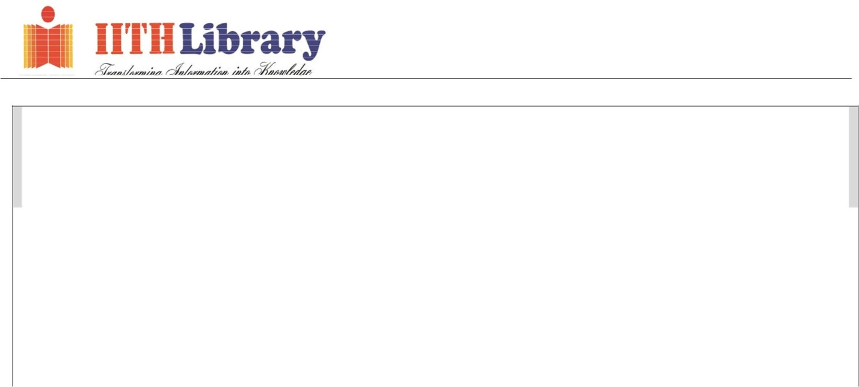

**Supervisor’s confirmation**

I support this student’s request to embargo their thesis/dissertation and believe that both the grounds for the embargo and the length of the embargo are appropriate.

Signed:

(First supervisor)

Date:

Signed :

(Student )

Date: 222 27/

|  |  |  |
| --- | --- | --- |
| **------------------------------ FOR OFFICE USE -----------------------------** | | |
| Uploaded in RAIITH No.: | □  □  □  □ | Preprint copies of articles published submitted  Preprint copies of articles published not submitted (time required):…………………………………………………  Articles not yet published  Student is not willing to share preprint copies |
| Date: |
| Signed : |
| (Staff ) |

Please Note:

1. Insert approval sheet duly signed by supervisor (digital signature is allowed) and include in the soft copy of the thesis.

IITH/LIB/2020